

OTIS Force Amplification System

WORCESTER POLYTECHNIC INSTITUTE

**Submitted by:**

Aashish Singh Alag (ME ‘23)

Zeb Carty (ME '24)

Achilles Gikas (BME/ME ‘24)

Karl Ghosn (ME '24)

Nikita Igoshin (BS/MS ME ‘25)

Cooper Lagner (ME ‘23)

Alexander Lucero (ME '24)

**Project Advisor:**

Pradeep Radhakrishnan (ME/RBE)

**ME 4320**

**12 December 2022**

# Abstract

This project explores building a force amplification system based on the preliminary design provided by OTIS. The project’s goal was to design and fabricate this system and test this system to verify the requirement of 40N input pull force and 2.5 times force amplification factor given to us for the safety system actuation.

Currently, the Electronic Actuation System provides an input pull force to activate the safety for the elevators. Due to factors like depreciation, malfunction, etc. the minimum input force that the ESA provides is 40N. Our task is to create a system between the ESA and the safety system to increase the pull force in case the actual pull force decreases to the mentioned 40N.

A force amplification system was created using the design constraints provided based on the space available on the side wall of the elevator car. We created a design based on the amplification factor constraints. This system was later prototyped and assembled to perform static and dynamic tests to verify the amplification and delay time response. A testing rig was created to simulate the input force using weights and gauge the output force for the system.

Based on the results for the static and dynamic test, the team will provide verification for the functionality and performance for the mechanism created.

# Acknowledgments

Our team would like to thank OTIS for sponsoring this project and providing assistance and expertise during the data collection stage. We would also like to thank Professor Pradeep Radhakrishnan and Teaching Assistant Tessa Lytle for their assistance throughout the duration of our project.

# Executive Summary

Our team had been given the task to design and test a force amplification system that would be incorporated in the elevator emergency brake system. To effectively approach designing this amplifier system, our team first developed a set of deliverables for the project.

Our deliverables to OTIS include the following:

* Design and fabricate:
  + Force amplification device using rack and pinion system
  + Test rig to effectively test the force amplification design
* Test the force amplification device for:
  + 2.5x amplification factor
  + Time to transfer force
  + Time to travel 65mm
* Provide testing plan and recommendations to the given system:
  + Static testing
  + Dynamic testing
  + Testing protocols and recommendations

To create an amplification model, the team performed rack and pinion analysis to obtain the gear module, number of teeth, and gear transmission. These design specifications are used to find appropriate gear on the gear catalogue to order or manufacture those gear. For our initial design we obtained the gear specs from gear catalogues based on the space constraint to 3D print the prototype. The prototype was used to check the envelope interference and transmission for our system. Further, we assembled the whole system using components ordered from gear catalogues. Initially our team created an envelope using laser cut wood. Since the structural integrity was contentious, we also created a steel envelope by welding cut steel sheets. Since the Steel envelope was handmade, the envelope holes and lengths were not precise. Thus, for precision, we went with the laser cut envelope and reinforced it with l-brackets. The components were attached to the envelope which was then mounted on the testing rig for force amplification verification.

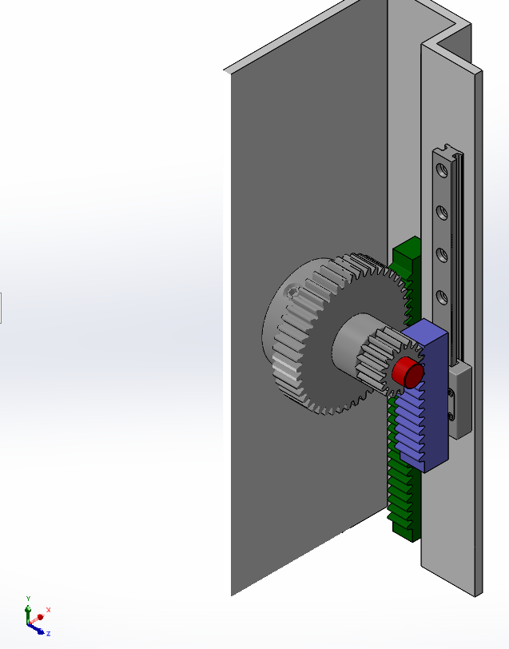

Figure 1: Section view of force amplifier

The testing rig was designed to apply an input force of 40 N. The structure supports a full-scale amplification mechanism and can perform multiple tests to validate the function of the amplification devices. The first test is the static test where the output bar is fixed to the structure, this is how our team gets measurements for the amplification factor and the time to transfer load. The next test is the dynamic test, where the amplification system was tested for travel distance and travel time.

Overall, the team was successful in design and fabrication of both the rack and pinion system and the testing rig. This rack and pinion system can produce a 2.5 amplification factor. Estimates of the time to transfer load and time to cover a reduced travel distance are provided in this report.

# Contents

Abstract ii

Acknowledgments iii

Executive Summary iv

Contents vii

List of Figures 1

List of Tables 3

1. Introduction 4

1.1. Mission Statement 4

1.2. Project Goals 4

2. Background and Literature Review 6

2.1. Relationship between Electronic Safety Actuation (ESA) and mechanical amplifier 6

2.2 Rack and pinion 10

2.3 Types of gears and gears information about dimensions 10

2.4 General information about bearings 13

3. Methodology 14

3.1. Phases 14

3.2. Design and Implementation 14

3.2.1 Force Amplifier Constraints 14

3.2.2. Expected Motion 15

3.2.3. Gears 16

3.2.4. Racks 18

3.2.5. Carriages and Rails 19

3.2.6. Shaft and Bearings 21

3.2.7. CAD 23

3.2.8. System Simulation 29

3.2.9. Material Selection 30

3.2.10. 3D printed prototype 32

3.2.11. System enclosure 33

3.2.12. Assembly 35

4. Analysis and Result 37

4.1. Static Testing Procedure 37

4.2. Dynamic Testing Procedure 38

4.3. Static Testing results 39

4.4. Dynamic Testing results 41

5. Testing Rig 42

5.1. Design Concepts 42

5.1.1. Requirements 42

5.1.2 Design Process 42

5.1.3. Component Analysis 55

5.1.4. Failure Mode & Effect Analysis (FMEA) 56

5.2. Testing 59

5.2.1. Rig Assembly 59

5.2.2. Force Data Collection 60

5.2.3. Input Force Calibration 61

5.2.4. Static Test 62

5.2.5. Dynamic Test 63

6. Recommendations 65

6.1 Force Mode and Effects Analysis (FMEA) 65

6.1.1 Bearings 66

6.1.2 Carriage/Rail, Shaft, and Fasteners 67

6.1.3 Gears and racks 68

6.2. Test Rig Recommendations 69

6.2.1 Design 69

6.2.2 Measurement 70

6.2.3 Operation 71

7. Conclusion 72

8. Reflection 73

Appendices 76

Appendix A: Authorship Table 76

Appendix B: COTS Analysis 78

Appendix C: Arduino Code 81

References 83

# List of Figures

Figure 1: Section view of force amplifier v

Figure 3: ESA Physical Diagram 6

Figure 4: FAM system's parts 7

Figure 5: Force amplifier location 9

Figure 6: Meshing of Gears 12

Figure 7: Rack teeth parameters 13

Figure 8: Force amplifier working envelope 15

Figure 9: Dimensions for the larger gear 17

Figure 10: Dimension for the smaller gear 18

Figure 11: Dimension for the rack ordered 19

Figure 12: Dimensions for the sleeve bearing carriages 20

Figure 13: Dimensions for the 7mm wide guide rail 21

Figure 14: Shaft dimensions 22

Figure 15: Bearing Dimension 23

Figure 16: Front view of the assembly 24

Figure 17: Side view of the assembly without the envelope 25

Figure 18: Top view of the assembly 26

Figure 19: Front view of force amplifier in the test rig 27

Figure 20: Left view of the force amplifier in the test rig 28

Figure 21: Isometric view of the force amplifier in the test rig 29

Figure 22: Tangential force applied on tooth 31

Figure 23: Stress/strain diagram of various metals. Reference (d) 32

Figure 24: 3D printed gears and rack. 33

Figure 25: Retention box of force amplification system 34

Figure 26: Retention box mounted to testing rig 35

Figure 27: Graph of input force 40

Figure 28: Graph of output force 40

Figure 29: Planning schematic of testing rig structure, with three subsystems shown 43

Figure 30: Testing rig structure SolidWorks assembly 44

Figure 31: Testing rig input subassembly concepts with labels. 46

Figure 32: Testing rig input subassembly modeled in SolidWorks. 48

Figure 33: Initial design of output subsystem in SolidWorks. 50

Figure 34: Output assemblies 51

Figure 35: Deployed testing rig SolidWorks assembly 52

Figure 36: Original setup with Arduino and TF Luna 53

Figure 37: Arduino Mega board with two TF Luna sensors 54

Figure 38: Changes to the test rig based on FMEA 58

Figure 39: Trials for input weight validation. 62

Figure 40: Static test setup with output bar fixed 63

Figure 41: Dynamic test setup with output bar free 64

Figure 42: Bearing FMEA 67

Figure 43: FMEA for carriage, rail, shaft, and fasteners 68

Figure 44: FMEA for gear and rack 69

Figure 45:Resultant load diagrams from Reference (a), Section 4.2 78

Figure 46: Formula for testing rig pulley configuration from Reference (a), Section 4.2 78

Figure 47: Pulley analysis 79

Figure 48: Shaft analysis 80

Figure 49: Fastener analysis 80

Figure 50: Setup and Variable Initializing at startup 81

Figure 51: Looping Code for Sensors 1 and 2 82

# List of Tables

Table 1: Response time testing 41

Table 2: Design considerations for testing rig with imposed solutions 42

Table 3: Decision matrix for input force application 47

Table 4: Criteria table for decision matrix 47

Table 5: FMEA table with recommended solutions 56

Table 6: Trials for input weight validation. 61

Table 7: FMEA criteria for amplification system 65

# 1. Introduction

## 1.1. Mission Statement

OTIS, the world's leading manufacturer, installer, and service provider of elevators, is always looking for ways to improve the safety and efficiency of their elevator system. OTIS reached out to WPI in search of students to work on a complex engineering problem for further developments in their safety mechanisms.

Currently, OTIS elevators utilize the centrifugal overspeed governor subsystem and safety actuation module with safety linkages and lift rods. This governor subsystem is prone to false responses to the safety logic which can cause unnecessary emergency stops when overspeed conditions are erroneously simulated, resulting in unnecessary passenger entrapment. To resolve such issues, OTIS created and is working on improving the Electronic Safety Actuation (ESA), which electronically detects over speeding and electro-magnetically activates the safety gear. While similar in effect to the previous safety system, the ESA is limited in its force output, because of this it was necessary to increase the pulling force generated to increase safety factors without changing the overall design of the ESA.

## 1.2. Project Goals

The goal of our project was to design, fabricate, and test a force amplification system for use with the ESA device. The force amplification system is designed to function with a minimum of 40 N input pull force while providing an amplification factor of at least 2.5.

To accomplish this, designs were prototyped under the specified dimensional constraints provided by OTIS, in order to determine the amplification factor. We then fabricated a system with materials and methods that would enable fast prototyping and testing. In order to determine whether the system would successfully increase the force by the desired amplification factor, we also developed a testing plan. This test plan consists of a testing rig, fixtures, and measurement techniques, ideally with the ability to gauge amplified force response delays.

# 2. Background and Literature Review

## 2.1. Relationship between Electronic Safety Actuation (ESA) and mechanical amplifier

The OTIS ESA system includes a commercial precision relay sensor (PRS) which provides a car speed signal, a safety actuation board (SAB), force actuation module (FAM), and mechanical gear amplifier (MGA). The following figure (number) shows these parts.

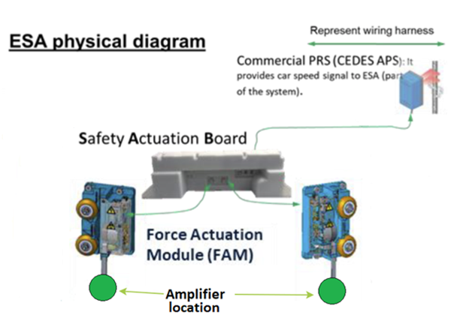

Figure 2: ESA Physical Diagram

The FAM system has the following essential parts: signal wires, friction pads, electromagnets (EM), and permanent magnets (PM). (Fig. number)

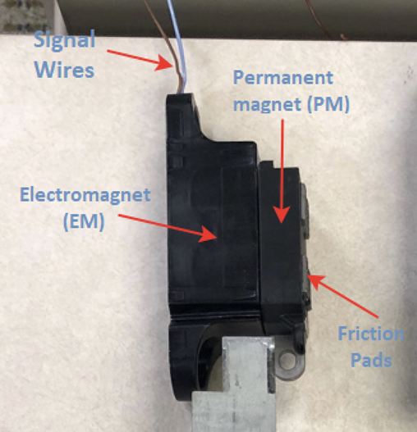

Figure 3: FAM system's parts

The principle of system operation has the following multiple steps: The SAB gets a signal from the PRS that the car is falling, the SAB sends a signal that changes the magnetic flux in the EM, and the EM causes PM to be pushed to the rail surface and connect the rail to the four friction pads. The friction pads have a diamond surface that increases the frictional force generated by their motion along the rails which, under ideal conditions, should be a minimum of 80 Newtons. Because environmental changes like rust build-up can decrease the friction force generated by the brake pads, our mechanism's input force was designed to be half of the ideal minimum force value. The force amplifier multiplies the 40N input force by at least 2.5 times, so the output force is greater than or equal to 100N. This amplified force activates the safety system, and the brake pads stop the car. The figure shows the following important components: the location of the mechanical gear amplifier (between two yellow lines), the FAM, and the brake pads.

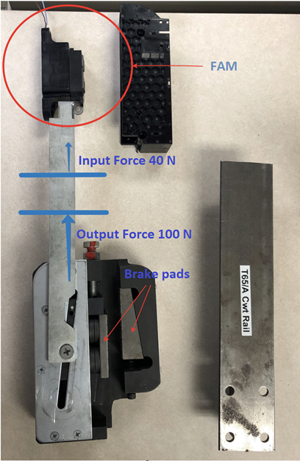

Figure 4: Force amplifier location

## 2.2 Rack and pinion

The rotational-translational gear constrains the pinion and rack to, respectively, rotate and translate together with a conversion ration that we can specify by the relative size of the pinion to the input gear. Using the rack direction parameter, we can also determine whether the rack axis moves in a positive or negative direction as the pinion rotates in a positive direction.

Under ideal conditions, the rack and pinion impose one kinematic constraint on the two connected axes represented by the following equation:

$$ω_{P} = R_{RP}⋅v_{R}$$

Here $ω_{P}$ is the angular velocity of the pinion shaft, $R_{RP_{}}$ is Rack-Pinion gear ratio and is the translational velocity of the rack.

The transmission ratio is:

$$R_{RP} = \frac{1}{r_{P}} = \frac{ω_{P}}{v_{N}}=\frac{2π}{N_{P}⋅v_{R}}$$

Here $r_{P}$ is the effective radius of the pinion and $N_{P}$ is the number of teeth on the pinion.

In a non-ideal condition, the friction losses are not negligible. Although the angular velocity and geometrical constraints are unaffected, the Coulomb friction between the teeth surfaces and the viscous coupling of driveshafts with bearing reduce the transferred torque, force, and power.

## 2.3 Types of gears and gears information about dimensions

There are two primary types of gear for rack and pinion systems: spur gears and helical gears, our system uses two spur gears. The spur gears in our system share the same tooth size and angle as that simplified construction and calculations. The main two parameters for our calculations were the module and pitch diameter of the gears. The module defined the tooth's size, and pitch diameter is crucial in determining torque ratio. A larger module indicates a larger tooth size for the gear. The module can be calculated in SI system according to the following formula; module is in millimeters (P734):

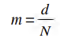

Where m- module; d- pitch dimeter; N- number of teeth.

The torque ratio or mechanical advantage can be calculated through the following formula (P728):

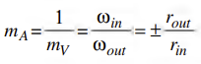

Here $m_{A}$ is the torque ratio; $ω_{in}$ is the input angular velocity; $ω_{out}$ is the output angular velocity; $r_{in}$ is the pitch radius of the input gear; $r_{out}$ is the pitch radius of the output gear; and $m_{V}$ is the velocity ratio. Because the gears in our amplifier are fixed onto the same shaft, the torque ratio can be obtained by the ratio of the pitch diameters for our system. Therefore, the gears have the same angular velocity but different linear velocities at the point of coincidence with their respective.

According to the fundamental law of gearing and forces, "The angular velocity ratio between the gears of a gearset must remain constant throughout the mesh"; Since our system uses gears meshed with racks, we have a constant line of force transmission through the connection. (P 727) While helical gears were not selected for our assembly, the most significant advantage of the helical gears type is that they have a larger contact line between the gears. As a result, they are more effective at transmitting force than spur gears. The second advantage of the helical gears is that they are quieter than the spur gears.

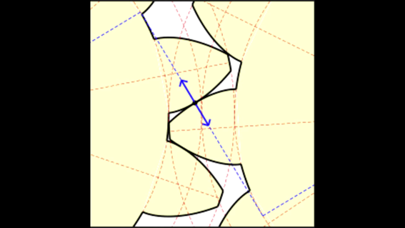

Figure 5: Meshing of Gears

The pressure angle (Ф) in gears has standard values of 14.5, 20, and 25, where 20 degrees is the most used. Other gear parameters such as addendum and dedendum do not play significant role for our project because we purchased gears whose dimensions where provided based on module and tooth pressure angle, in addition to diameter.

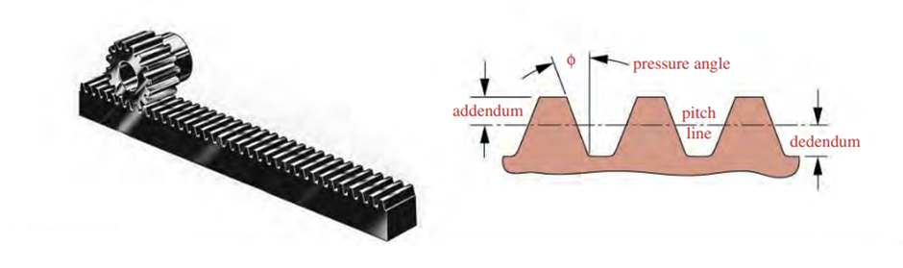

Figure 6: Rack teeth parameters

## 2.4 General information about bearings

Most ball bearings are made from AISI 5210 steel. Roller bearings, which were selected for our application, are made from AISI 3310, 4620, and 8620 steel alloys. ANSI/AFBMA standards 9-1990 for ball bearings and 11-1990 for rolling bearings define the quality of bearings by class. Radial bearings are classified by ANSI 1-9 tolerance classes, where class 9 is the most precise bearing type. ISO is classified from Class 6 to Class 2, where Class 2 is the most precise bearing type. When choosing the bearing type for an engineering application it is essential to define the portion of radial and axial forces acting on the bearing because some bearing types can only handle radial forces. Ball and roller bearings are ideal for applications involving axial loads as these bearings can withstand higher axial force loads than other bearing types.

# 3. Methodology

## 3.1. Phases

After background research and clarification of the mission statement, the phases of design were separated into 6 discreet steps:

1. Formulation of requirements and tasks
2. Deliberation of design considerations/brainstorming
3. 3D-modeling
4. Prototyping
5. Testing
6. Fabrication of final assembly

## 3.2. Design and Implementation

### 3.2.1 Force Amplifier Constraints

We created the force amplifier within the space constraint provided to us by OTIS, based on the space available between the ESA and the safety. The dimensions for the space available are 185mm x 64.5 mm x 42 mm. Another constraint was the maximum vertical travel distance of 65 mm.

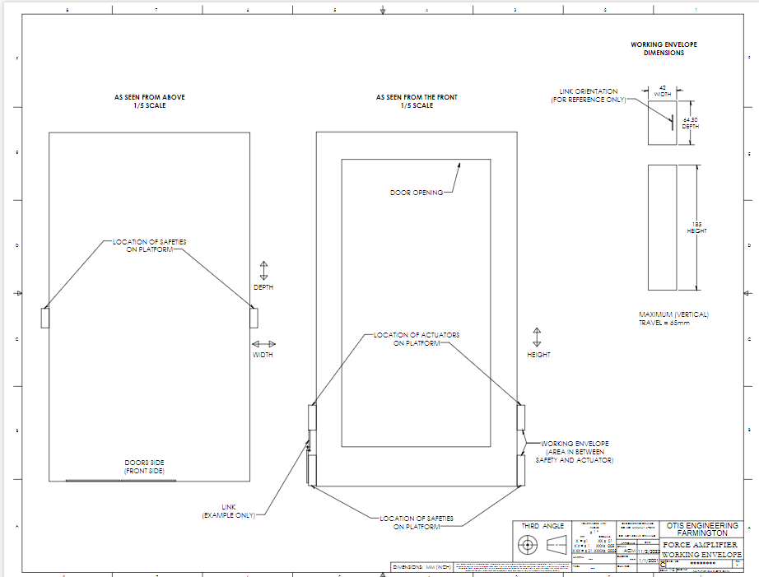

Figure 7: Force amplifier working envelope

### 3.2.2. Expected Motion

There are two types of motions in our assembly. The first type is the linear vertical motion of the racks, which are attached to guides and slide on rails screwed vertically to the frame. The second type of motion is the rotation of the gears. The two gears are fixed to an aluminum shaft which rotates about its axis, fixed in place by two ball bearings at its extremities. Once the input rack is subjected to a vertical force, it moves up rotating the gear mechanism which in turn raises the output rack upwards. The size difference between the gears results in the input force being amplified by 2.7 times.

### 3.2.3. Gears

The gears have been selected based on the transmission ratio required for the amplification factor for our system. For our project we initially 3D printed the gears for our prototype, but we purchased steel gears from McMaster-Carr for the testing version of the assembly. We selected metal gears with 20-degree pressure angle, since this pressure angle provides additional power transmission capacity, better lubrication in the gear mesh, and a reduced number of teeth for the pinion without undercutting. Since this type of gear has a wider base, it also provides additional load capacity.

For our larger gear we selected a gear made of 1045 Steel with a module of 1 and 45 teeth with a 20-degree pressure angle. The gear dimensions can be found in the figure below.

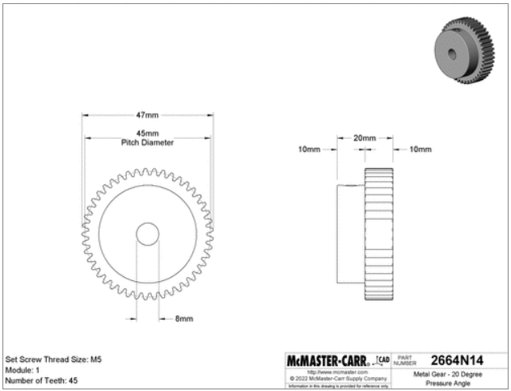

Figure 8: Dimensions for the larger gear

For the smaller gear, we selected a gear made of 303 stainless steel with a module of 1 and 16 teeth with 20-degree pressure angle. The gear dimensions can be found in the figure below.

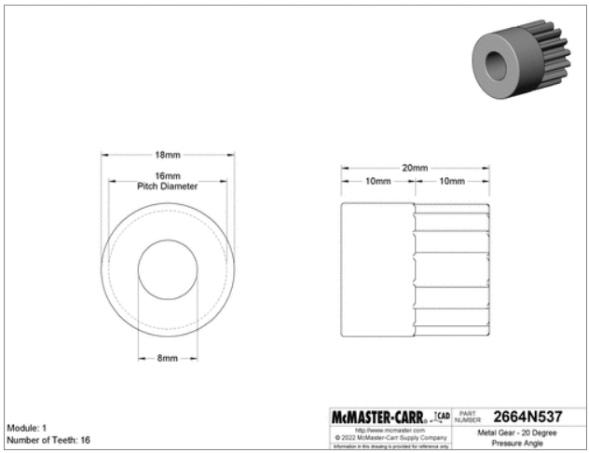

Figure 9: Dimension for the smaller gear

### 3.2.4. Racks

For this project we utilized a metal gear rack with a 20-degree pressure angle with the same module as the gear. The racks were initially 3D printed for testing purposes but were later replaced by steel gears purchased from Mc-Master Carr. The racks that were ordered each had a 20-degree pressure angle with a module of 1, an 11 mm pitch height and a length of 100 mm. The racks were then cut to the required lengths of 92 mm and 45 mm using an angle grinder.

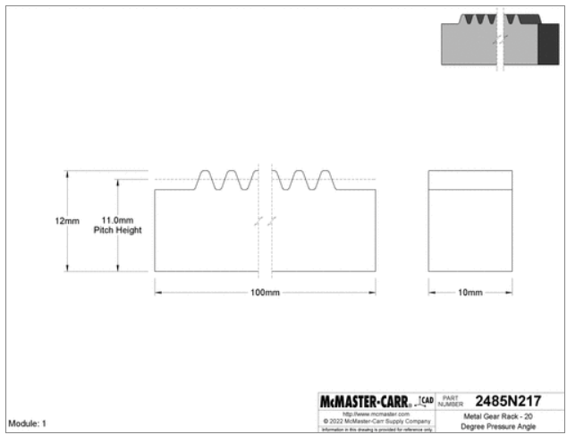

Figure 10: Dimension for the rack ordered

### 3.2.5. Carriages and Rails

To confine the motion of our racks we utilized a carriage and rail system where the racks were fixed to carriages which slid on rails mounted vertically to the envelope wall. For our design we attached the carriages to the back of the racks using epoxy as the carriages available did not have appropriate mounting holes to attach them to our racks. We ordered the carriages from McMaster-Carr based on the dimension constraints of the envelope. The selected carriages were 17 mm wide with an internal rail dimension of 7 mm and made of zinc.

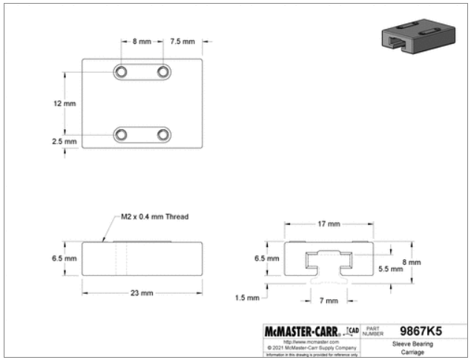

Figure 11: Dimensions for the sleeve bearing carriages

Similarly, we ordered the rails based on the size constraints. These rails run along the wall of the envelope to facilitate the motion of the input and output racks. The rails were constrained to the envelope using M2 mounting fasteners. We ordered 7mm wide guide rails which are 250mm long and made of anodized aluminum. These rails were then cut into two smaller rails for both the racks.

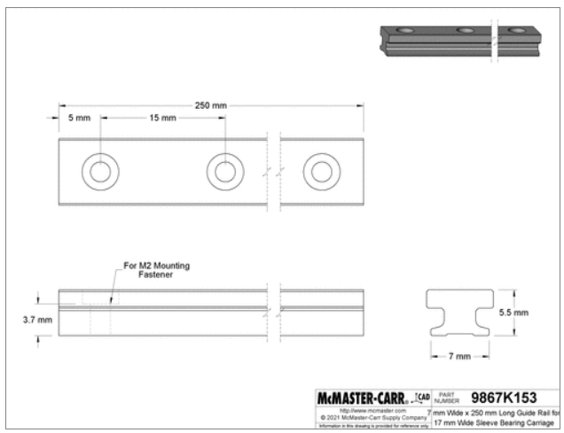

Figure 12: Dimensions for the 7mm wide guide rail

### 3.2.6. Shaft and Bearings

We selected the shaft for our system based on the shaft diameter for the chosen gears. An 8 mm shaft with tight tolerance made of 6061 aluminum was ordered based on these specifications. The shaft was originally 1 ft long but was cut to 52 mm to fit our envelope width.

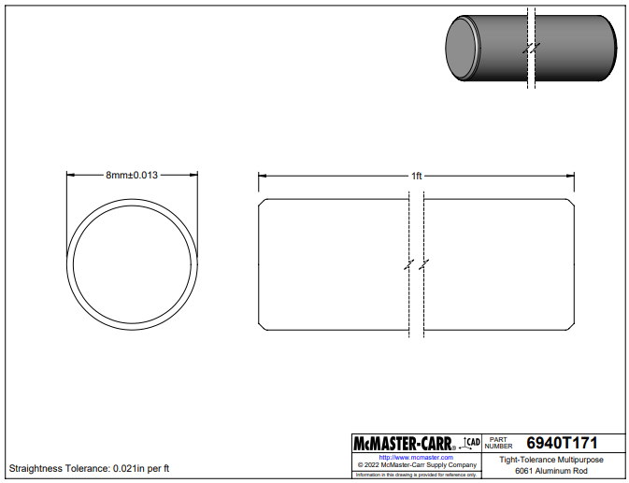

Figure 13: Shaft dimensions

For our system we used stainless steel ball bearings for an 8mm shaft diameter. We used two bearings which were attached to our system envelope using epoxy.

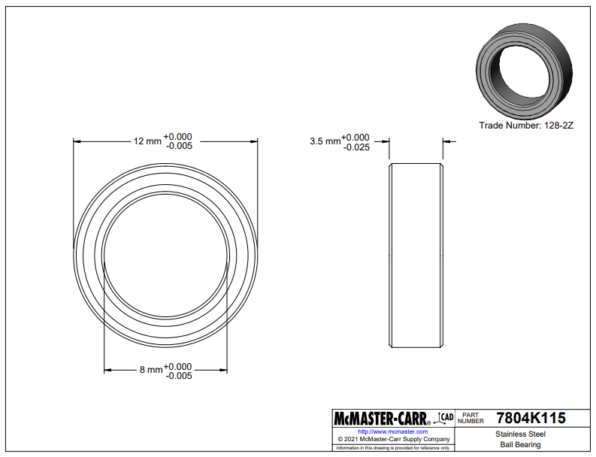

Figure 14: Bearing Dimension

### 3.2.7. CAD

The CAD assembly for the amplifier was created using the part files obtained from McMaster-Carr for the parts we ordered. To create the assembly, we first created an outline of the external dimensions of the envelope based on the dimensions that were given to us. Then we downloaded the parts from McMaster and put the gears, racks, shaft, guides, and rails together inside the frame. Finally, we combined the testing rig model with amplifier assembly model to view the completed system.

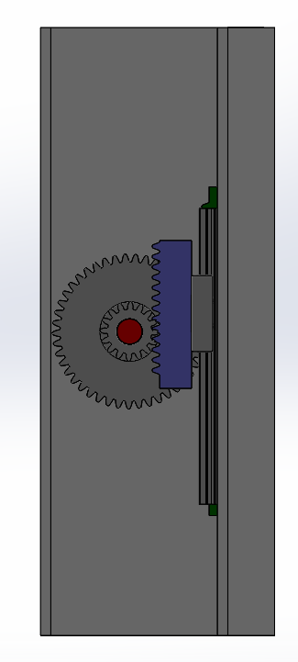

Figure 15: Front view of the assembly

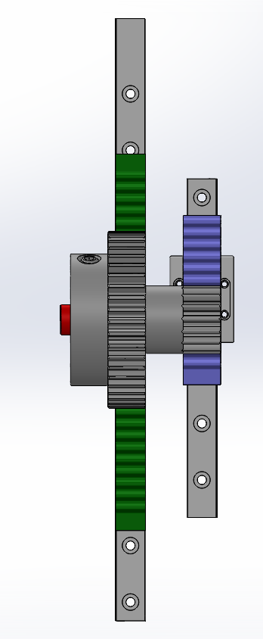

Figure 16: Side view of the assembly without the envelope

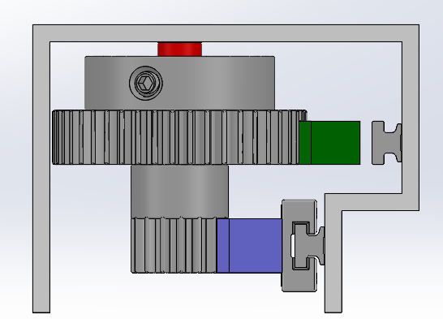

Figure 17: Top view of the assembly

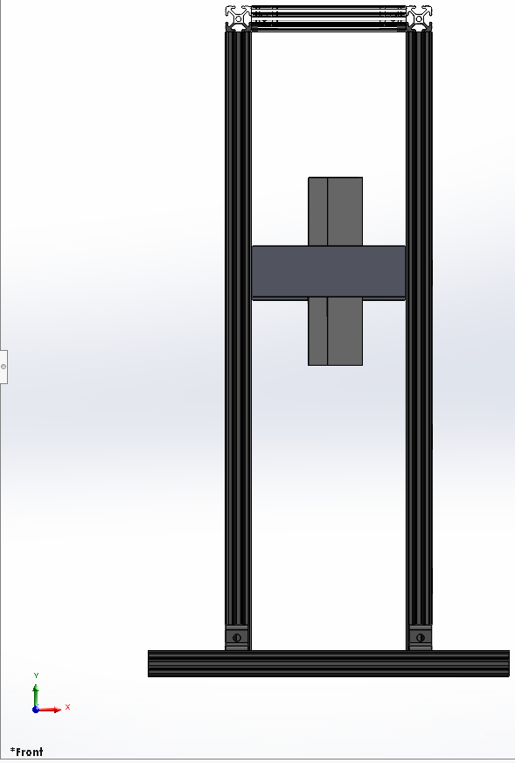

Figure 18: Front view of force amplifier in the test rig

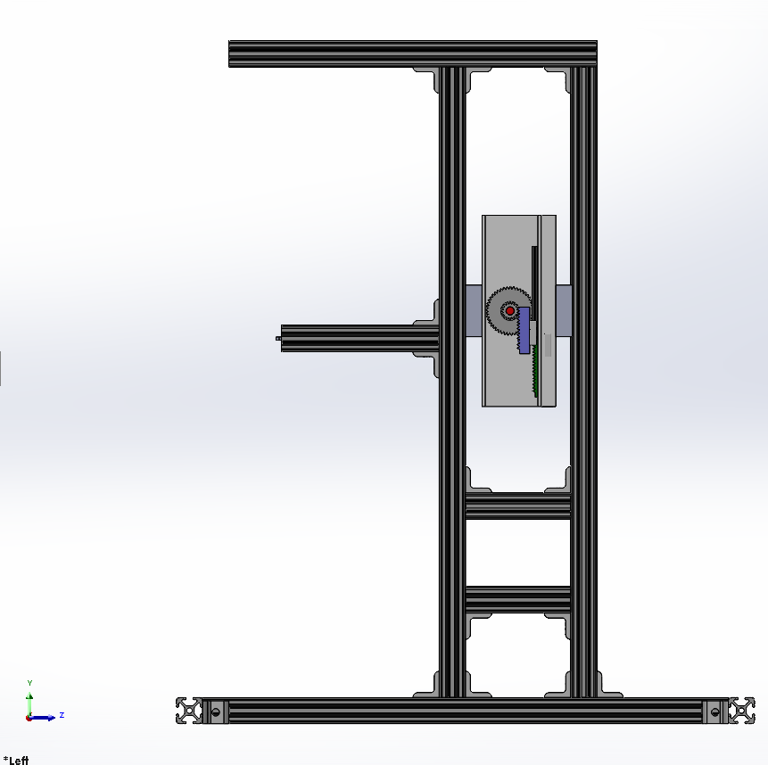

Figure 19: Left view of the force amplifier in the test rig

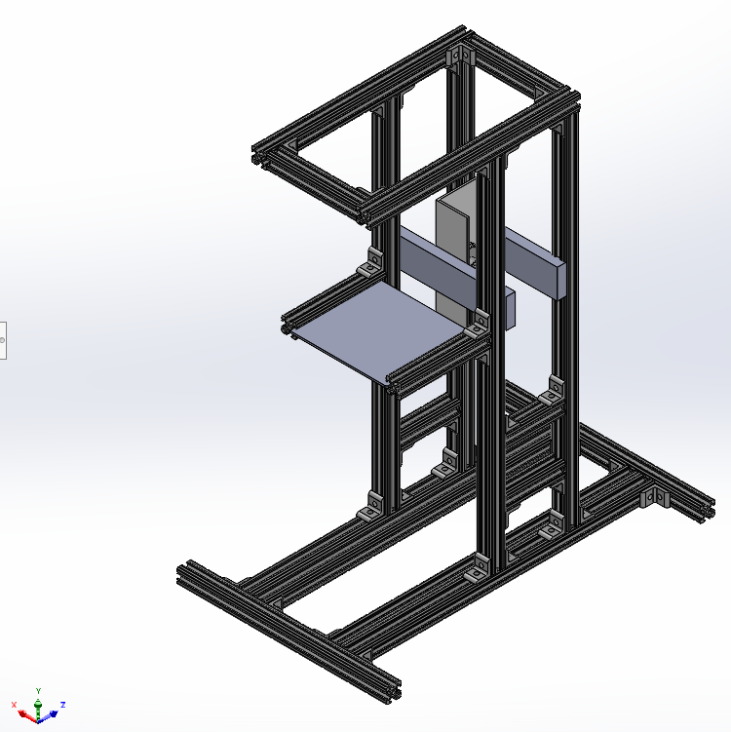

Figure 20: Isometric view of the force amplifier in the test rig

### 3.2.8. System Simulation

The CAD assembly was simulated in SolidWorks in order to view the travel of the amplifier components and their relative motion. To facilitate this process the racks where constrained by their distance to the bottom of the amplifier, and the rest of the assembly was mated such that its motion was dependent on the location of the input rack. The distance between the bottom of the amplifier and the input rack was then manipulated using a mate controller to produce the desired motion for the simulation.

### 3.2.9. Material Selection

The Lewis Equation for bending stress in a gear tooth can help to determine the minimum face width of the tooth and material selection. Page 752 of Reference (b). (P 752)

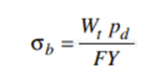

Explanation of dimensions Page 734 of Reference (b).

Wt – tangential force on the tooth

pd – diametral pitch = N/d where (N – number of teeth, d – pitch diameter)

F – face width

Y – dimensionless geometry factor

For contact ratios > 1, there will be the highest point of single-tooth contact (HPSTC) somewhere below the tip, and this will create the maximum bending moment on any one tooth, provided that the gears' accuracies are good enough to allow load-sharing.

The next figure represents the tangential force on the tooth, which equals 40 N in our case. The factor Y depends on different pressure angles and numbers of teeth.

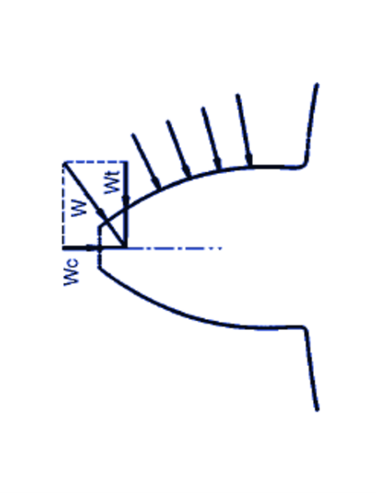

Figure 21: Tangential force applied on tooth

As the module of elasticity is bigger for steel than aluminum, we can use smaller gears in our system if we use steel for the gears. Since McMaster gives all of the required parameters of the gears, we can be sure that the our gears’ teeth meet the minimum required width.

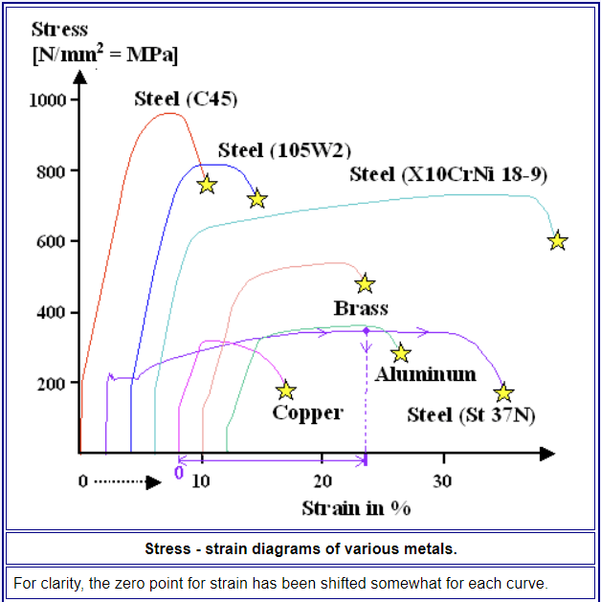

Figure 22: Stress/strain diagram of various metals. Reference (d)

### 3.2.10. 3D printed prototype

For our initial prototype we decided to print the parts using a resin printer. To accomplish this, we utilized the Elegoo Mars 2 Pro DLP printer with print area of 5in x 3in x 6in with tolerance of 0.05 mm. We used eSUN hard tough resin, with hardness of 75-81 D and tensile strength of 30-60 MPa which was suitable for our prototype. We printed the gears on the shaft to avoid the use of additional fasteners for our prototype. We also printed the racks to simulate the motion of the system. Both can be seen in the figures shown below.

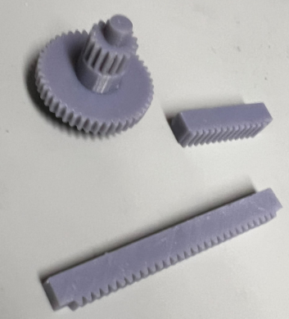

Figure 23: 3D printed gears and rack.

### 3.2.11. System enclosure

The system enclosure needed to be built with accuracy and have precise dimensions. Our first option was plywood since it can be laser cut with the given dimensions of our cad model, and in general easy to work with. Laser cutter instructions were created using the SolidWorks assembly model. The product was 6 pieces with finger joints on the edges creating a set of complementary interlocking profiles. Holes were then drilled for fastening the rails to the frame, and the frame to the testing rig. After the assembly was glued and assembled there were concerns about its rigidity. To fix this issue we decided to create a welded steel frame. While the steel envelope was stronger than the wooden frame, its dimensions were not as precise, and it was harder to drill the holes accurately. Because of these issues we ended up using the wooden laser cut frame, but we reinforced it with L-braces on its edge to eliminate play and provide additional strength.

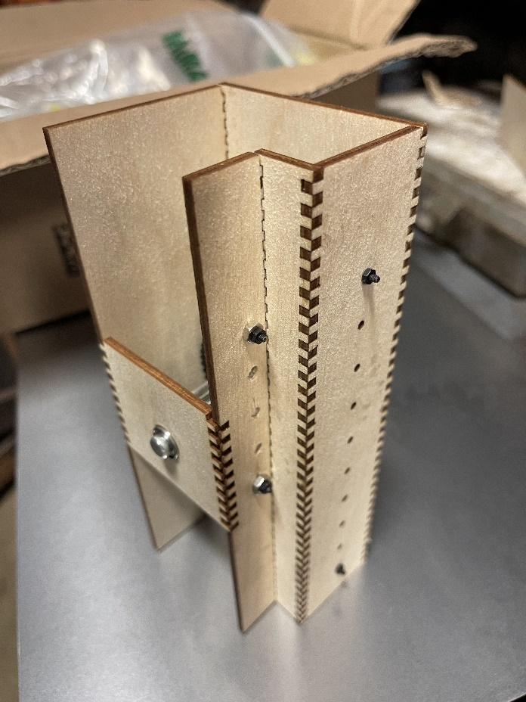

Figure 24: Retention box of force amplification system

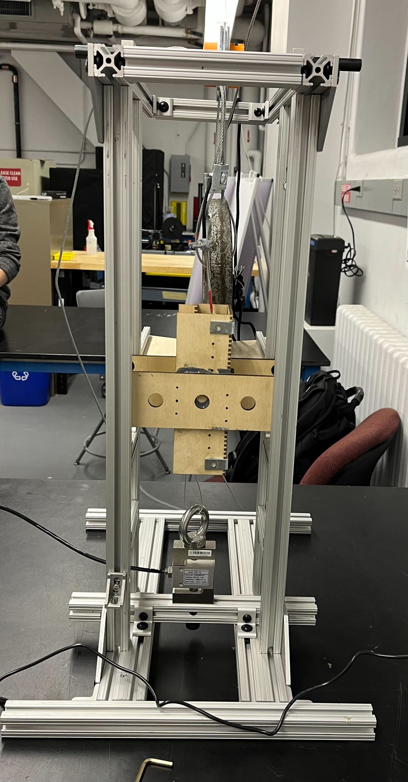

Figure 25: Retention box mounted to testing rig

### 3.2.12. Assembly

The assembly can be divided into two: the shaft and gears, and the bearings and the box.

The input gear was fixed to the shaft with a bolt that goes radially inside the gear. The output gear didn't have that option, and it would've been hard to machine it and use the same method, so JB-Weld (epoxy) was used.

The box was glued with conventional glue at first, to give it a steady shape, then L-Braces were used for reinforcement and maintaining the 90º angle required between the sides. The two rails were bolted vertically to constrain the linear motion of the racks. Two ball bearings were also fixed in their slots, allowing the mechanism to rotate freely, leaving us with an infinitesimal friction force on the rotation of the shaft.

The backside of the racks was grinded a millimeter, just enough to make a slot in order for the guides to fit in. The guides were epoxied in place, leaving us with a durable and reliable design that can withstand the required number of working cycles.

# 4. Analysis and Result

## 4.1. Static Testing Procedure

Static testing procedure

1. Ensure that the surface that the testing rig is on is level
2. Mount the mechanical amplifier onto the test rig and tighten the attachment bolts.
3. Ensure that the amplifier assembly is mounted at a level according to the surface where the testing rig is.
4. Measure the input weight (force) and write down the data.
5. Ensure the path of the steel cable will be connected vertically with the rack.
6. Make sure that there is an appropriate distance between the output force rack and the O ring to make measurements.
7. Connect the O-ring to the output rack of the amplifier using a steel cable.
8. Connect the test weight cable to the smaller cable and attach it to the input rack.
9. Insert the racks into the amplifier and hold them in place for cable adjustment.
10. Adjust the cable between the O-ring and the output link to ensure that there is no slack.
11. Remove all weight from the O-ring by holding the components off it and zeroing the force gauge.
12. Visually inspect the mechanism to ensure that both racks are properly aligned.
13. Remove all hands from the mechanism and prepare to release the weight.
14. Release the weight from the rest position and load the mechanism.
15. Record the data for 5 seconds with an interval of 0.1 seconds from the strain gauge output into the datasheet.
16. Reset weight for the next trial.
17. Repeat steps 9 through 13, 5 times to avoid the testing error.

## 4.2. Dynamic Testing Procedure

Dynamic testing procedure

1. Ensure that the surface that the testing rig is on is level
2. Mount the mechanical amplifier onto the test rig and tighten the attachment bolts.
3. Ensure that the amplifier assembly is mounted at a level according to the surface where the testing rig is.
4. Output bar will move during dynamic test, so it put on the lower aluminum side profiles
5. Set the travel distance with new aluminum side profiles on top, including the length of the profiles.
6. Calibrate Lidar sensors to ensure that the sensor will detect the output bar. Check for interference by looking at the data from the LIDAR sensor
7. Measure the input weight (force) and write down the data.
8. Ensure the path of the steel cable will be connected vertically with the rack.
9. Make sure that there is an appropriate distance between the output force rack and the O ring to make measurements.
10. Connect the O-ring to the output rack of the amplifier using a steel cable.
11. Connect the test weight cable to the smaller cable and attach it to the input rack.
12. Insert the racks into the amplifier and hold them in place for cable adjustment.
13. Adjust the cable between the O-ring and the output link to ensure that there is no slack.
14. Remove all weight from the O-ring by holding the components off of it and zeroing the force gauge.
15. Visually inspect the mechanism to ensure that both racks are properly aligned.
16. Remove all hands from the mechanism and prepare to release the weight.
17. Release the weight from the rest position and load the mechanism.
18. Record the data for 5 seconds with an interval of 0.1 seconds from the strain gauge output into the datasheet.
19. Reset weight for the next trial.
20. Repeat steps 11 through 16, 5 times to avoid testing errors.

## 4.3. Static Testing results

There were five tests of the input force and output force. The data was formatted in excel in an appropriate time range where there is a range of force values recorded from zero to the limit of the testing force. This data was recorded over a time range of 1 second. There were peaks at the beginning of the graph; however, their specific values can be ignored as they are a product of the shock load on the sensor due to the force input method. Since the weight was hand dropped, the acceleration of the system was slightly different every time. From the data table collected in our testing, was determined that the average input force was 41.2 N, and the average output force was 106.36 N. From these values the average force amplification was found to be 2.58.

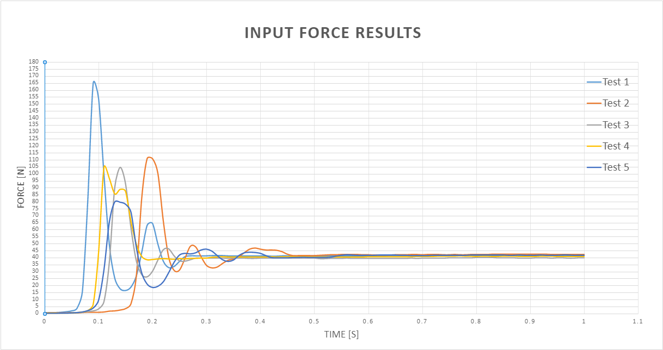

Figure 26: Graph of input force

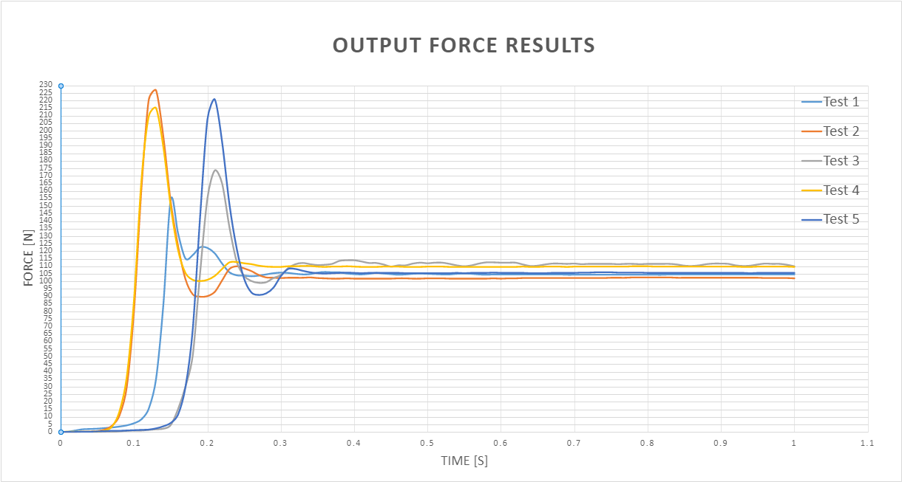

Figure 27: Graph of output force

## 4.4. Dynamic Testing results

The dynamic test was made with an iPhone 13, where input and output time was recorded to calculate time response.

Table 1: Response time testing

|  |  |  |  |  |
| --- | --- | --- | --- | --- |
| Test number | Input time [s] | Output time [s] | Time response [s] | Average time response [s] |
| 1 | .03 | .15 | .12 | 0.112 |
| 2 | .75 | .85 | .1 |
| 3 | .71 | .82 | .11 |
| 4 | .4 | .51 | .11 |
| 5 | .07 | .19 | .12 |

# 5. Testing Rig

## 5.1. Design Concepts

### 5.1.1. Requirements

The testing rig was devised to have requirements specific to design, fabrication, and testing. The rig must be designed to apply an accurate input force of 40 N. It must have a mounting system which is adaptable to each amplification design. It is important for the structure to support a full-scale amplification mechanism. The testing rig team needs to be able to fabricate the entire structure and mounts. In addition, the team must have the ability to wire and program the electronic systems required for measurement. To provide an accurate test for each of the amplification devices, the rig must be able to record the output force dynamically. This means each force value recorded must correlate to a certain timestamp throughout the test. The rig must also record the time it takes to travel the distance specified by each team.

### 5.1.2 Design Process

In order to create the testing rig, various design considerations were brainstormed from the listed requirements. Based off these design considerations, a basic plan of the testing rig could be created. The table with design considerations and solutions can be found below:

Table 2: Design considerations for testing rig with imposed solutions

|  |  |  |
| --- | --- | --- |
| Design Considerations | | |
| **Category** | **Considerations** | **Solutions** |
| Adaptability | * Adjustable to support multiple designs * Standard mounting * Supports full scale designs | * T-slot rail * Bracket |
| Input force | * Apply a 40 N force quickly and accurately | See Figure x |
| Measurement | * Measure deployment time * Measure travel distance * Measure output force | * Dynamic force output * TF Luna Sensor |

The design is separated into three subsystems: force input, amplification mechanism, and measurement system. A structure was created to both support these three subsystems and meet the requirement that our test rig structure needs to accommodate multiple designs. This also means accommodating a different position for the inputs and outputs of each design.

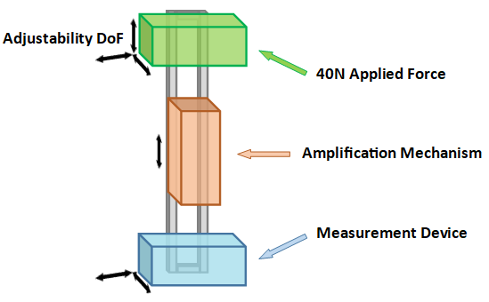

Figure 28: Planning schematic of testing rig structure, with three subsystems shown

#### 5.1.2.1. Structure

To meet this adaptability requirement, aluminum 1-inch square t-slotted bars were chosen as the material of choice for the structure as they provided rigidity and high adaptability, as sliders could be adjusted to any position and locked into place with a screw. There was also a ready supply of these bars at no cost, and for immediate use. In many instances throughout the design of the test rig, parts were chosen because they were readily available and in supply through the Mechanical Engineering Office, having parts on-hand led to significantly faster build times as there was no need to wait for parts to arrive. Parts that could not be sourced locally were purchased from supplier McMaster-Carr through the Mechanical Engineering Office.

After ideation, the test rig structure was modeled in SolidWorks. Space was allocated for each of the three subsystems and an assembly in SolidWorks was created for each subsystem. The height of the structure was decided as 26 in (660 mm) in height. This was partially based on materials accessible to the team, but also it was decided as valid height as this gives enough space for the 65 mm output travel distance and 195 mm of input travel distance. This leaves around 400 mm of space to accommodate the force gauge, connections and any other space needed for the mechanisms. The base of the test rig structure was designed extra wide to prevent the structure from tipping. Additionally, a double-wide t-slotted bar was used on each side of the base of the test rig so the output subassembly could have more space to be adjusted.

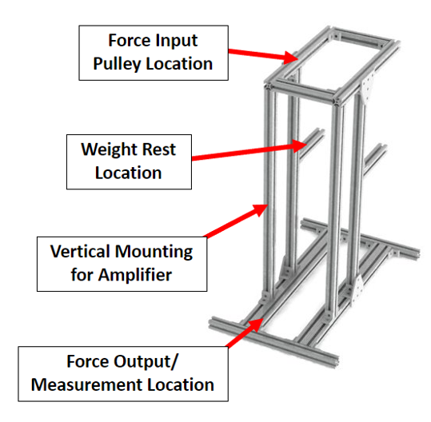

Figure 29: Testing rig structure SolidWorks assembly

#### 5.1.2.2. Mounting

In an Otis elevator, the amplification mechanism would be cantilevered, attached to the wall of the elevator. A cantilevered mounting design poses much more risk to the system than one that is supported on both sides. Due to the constraints of our budget, both groups are using lower-priced and lower-strength materials. It was decided amplification mechanisms should be supported on both sides to reduce risks and sources of error that could occur from the additional bending moments. Additionally, one of the requirements was that both amplification mechanisms need to be supported with a similar mounting system, so they could be easily swapped out. Because the mounting would now be supported on both sides, it was decided two mounting plates would be placed at a set distance apart and each team would connect to them. With the set distance, it would eliminate the need to modify the dimensions of the entire structure when a different mechanism would be tested.

To support the set distance between the mounting plates the test rig structure was modified to have four vertical beams at a set distance of 84 mm apart (in the x direction of figure x). This distance is the width of the envelope for the amplification devices plus 9.5 mm on each side for mounting plates and other amplifier structures. This design had the secondary benefit of improving the stability of the test rig structure. The additional vertical beams prevent bending and swaying at the top of the test rig.

#### 5.1.2.3. Input Force Subsystem

The design of the input subsystem started with ideation of different systems that would meet the requirements set by the test rig team. The input force needs to be accurate, consistent and be applicable to multiple types of mechanisms, in force applied to the amplifier. With these considerations in mind, initial ideas included the pneumatic, simple weight, and constant force spring systems. The initial concept drawings are shown in figure x.

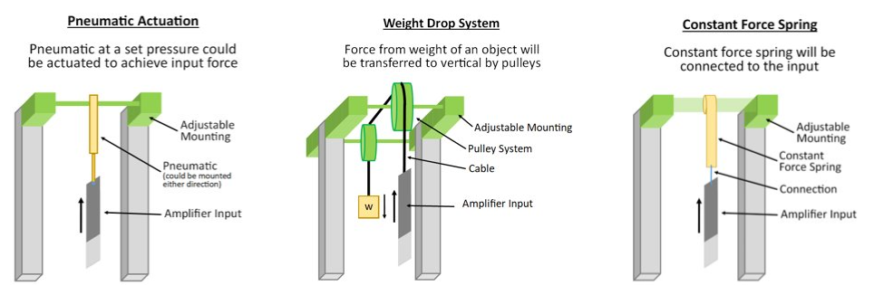

Figure 30: Testing rig input subassembly concepts with labels.

A decision matrix was used to determine which force application method would provide the most accurate test. Weights were assigned to each design consideration outlined in Table x, and final scores were calculated to ultimately determine that the simple weight system would be the most adaptable and repeatable mechanism for the test. For example, purchasing a pneumatic would require little work to integrate but due to time constraints, designing a pressure system and accurate synchronization would be very difficult. Additionally, a long pneumatic would make adaptability a big problem. In contrast, a simple weight and pulley system would allow us to apply our input force easily to both designs. The constant force spring was also a potential candidate, but it would be difficult to get accurate input force as constant force springs usually have high variability.

Table x:

Table 3: Decision matrix for input force application

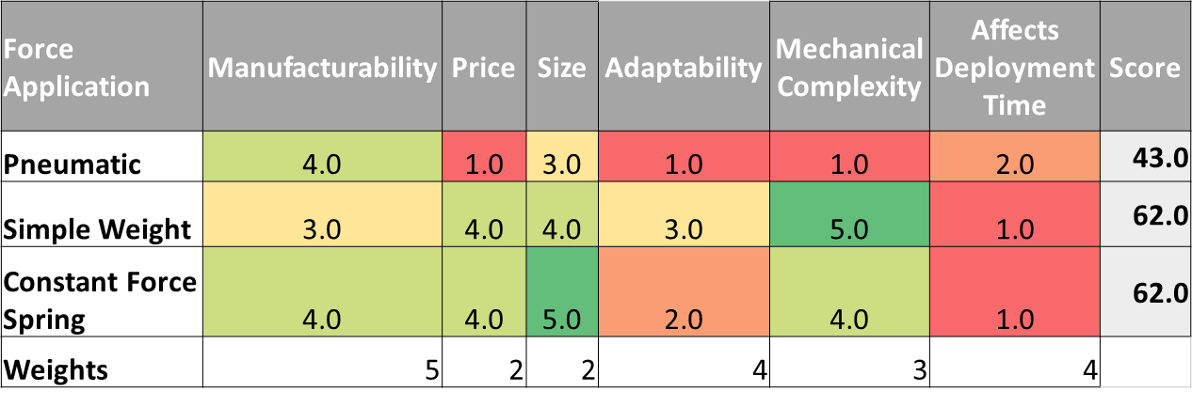

Table 4: Criteria table for decision matrix

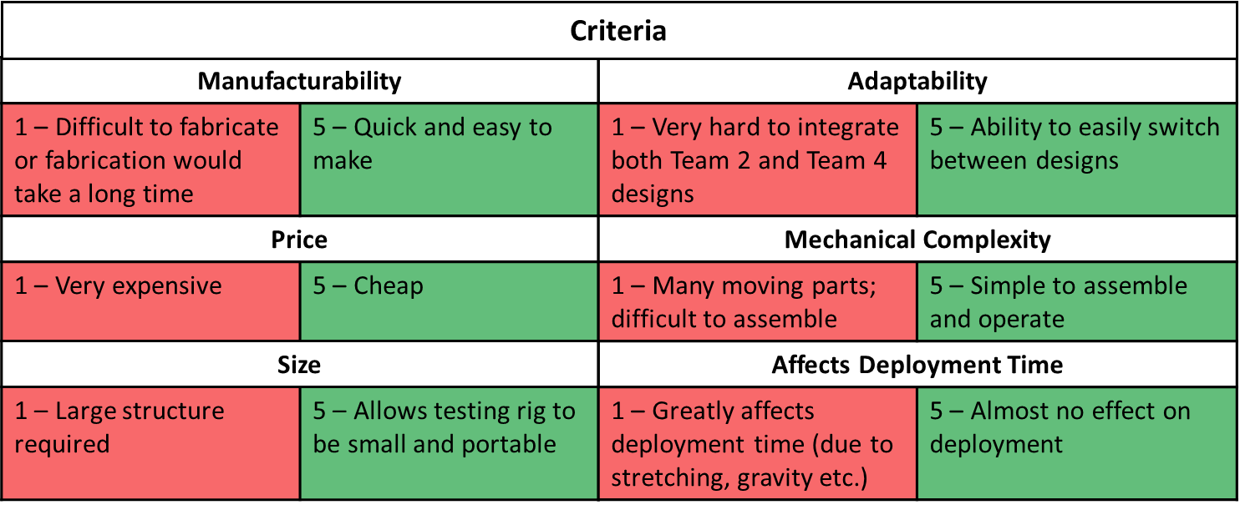

Based on the decision matrix, it was decided the weight drop system was the best choice for our team due to tight time constraints and high adaptability to any design. The next step in the process was creating the design of this weight drop system to apply a ~40 N force to the force amplifier. A two-pulley weight drop system was developed that would transfer the load of a dropped weight into an upward force into the amplification device. This system involves two 2" diameter pulleys each secured on 12" long, 0.5" diameter shafts. The pulleys were first fitted onto the shafts, then secured with 3D printed shaft collars to prevent movement along the shaft during testing. The shafts were then mounted to the top of the rig with t-slot rail compatible shaft supports the final assembly of this system is displayed in figure x.

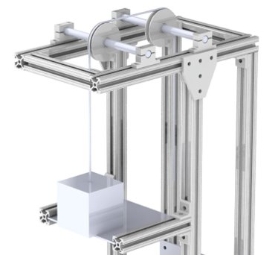

Figure 31: Testing rig input subassembly modeled in SolidWorks.

The pulleys, shafts, and shaft supports were all purchased from Mc-Master Carr. Once secured, we then ran a 1/8" wire rope through the pulleys to be secured to both the force amplifier and input weight. This was done with a set of two adjustable steel wire brackets, which allow the length of the cable to be adjusted as needed between designs. Before integrating these brackets with the input system, we validated through testing that the brackets could successfully hold 46 N of weight while undergoing the expected up and down motion. This test was performed by adding additional weights >120N and testing the bracket strength over a controlled drop surface. The brackets performed well with no slip in the cable, even when shock loading was induced. To improve consistency throughout testing, the drop will be initiated by removing a wood plate slotted between two t-slot rails.

#### 5.1.2.4. Output Force Subsystem

The force output subsystem is designed to provide a means to measure and record any required test results. The team set preliminary requirements specific to what data will be measured. Whichever force sensor is used must be able to measure at least 40 N, which is the input force for the test rig. In addition, there should be a sensor capable of measuring the time to cover a span of up to 65mm. The sensors should be able to export data to a computer so that a statistical and error analysis can be conducted for the trials. The sensors used in the test rig need to perform multiple trials for each design tested, and with the same accuracy and consistency in results.

The design of the measurement assembly is in response to the requirements set before. The initial concept was a singular system that would be able to provide a set travel distance and measure the force once it completed the required distance. This system included a custom machined slot that would sit on the top of the force gauge. During a test, a pin would be connected to the output of an amplifier mechanism and this pin would move up the slot, contacting the end of the slot after the required distance. The force once it steadies at the top of the slot would be the amplified force. The initial CAD model of this assembly is shown below in figure x.

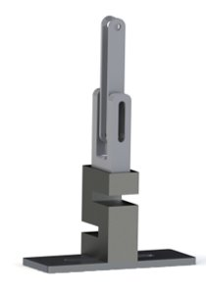

Figure 32: Initial design of output subsystem in SolidWorks.

While this assembly had potential, after a design review it was decided not to move forward with this design. Due to time constraints, the custom machined piece would be difficult to manufacture in a short time frame, and this piece will constrain the tests to a set output distance. While this is not a concern with different designs such as a pulley amplifier, the current rack and pinion system is not capable of achieving this actuation distance. Additionally, due to the motion of the racks, there would be interference issues unless a longer link was connected from the pin to the amplifier, greatly increasing the length of the entire assembly, and thus the height of the entire test rig structure would need to be raised.

A new design was developed which would use components readily available and still complete similar tasks. The final design features the force gauge mounted on the center of a t-Slot bar. The main component of the output subsystem is a force gauge. How this sensor works will be explained in more detail in the "Force Data Collection" section. Instead of accomplishing both distance and force testing at once, it was decided we would have two different configurations of the output assembly corresponding to the different tests and data that were being collected. This would be a static test, to measure the force amplification and response time, as well as a dynamic test to measure the distance the output will travel. In this design the t-slot bar and force gauge are used for both static and dynamic testing. For the dynamic distance test, 3D printed hubs were designed so additional weight could be added to the bar



Figure 33: Output assemblies

In both tests when the input weight is dropped tensile force is applied to the input of the amplification devices, which output a magnified force. The amplifier output is connected to the force gauge and the tension between the force gauge and this output is measured. It was decided the systems would be connected by cable. This allows for high adaptability to meet the requirement of the test rig system being used by multiple designs, as the cable length can be easily modified, and a cable would be easily able to attach to the existing M12 eye bolts on the force gauge. Because of differing connections, it was decided each team would use their own cable for connecting the amplification device to the output of the testing rig.

An overview of the entire system is shown in the following figure. The left configuration shows a testing rig ready to deploy and the right configuration shows the rig deployed with 40 N input force.

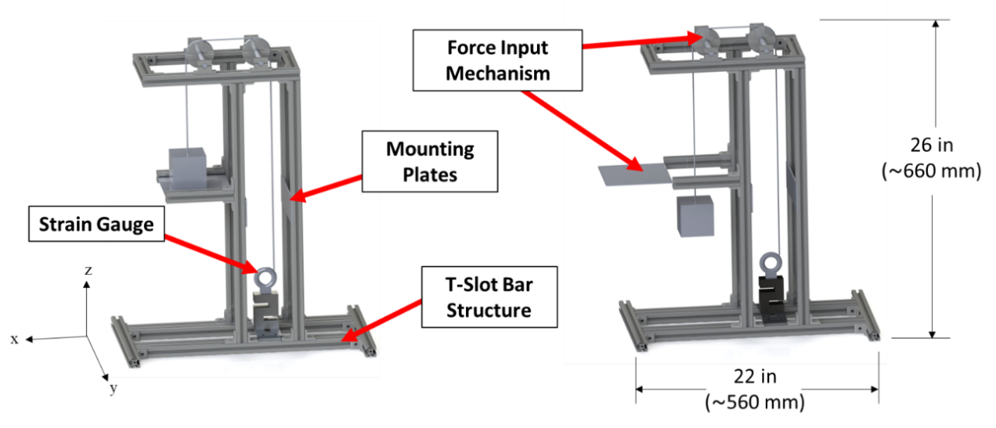

Figure 34: Deployed testing rig SolidWorks assembly

#### 5.1.2.5 Sensory

Our group started by researching the TF Luna sensor for measuring the travel distance. This is a LiDAR sensor that can provide precise light measurements. We weighed the pros and cons of a TF Luna sensor and an IR sensor. The IR sensor detects the radiation from an object in view and is much smaller than the TF Luna sensor. The TF Luna sensor has a low error range and takes a precise measurement. Its main function is to check if its line of sight is clear or blocked by another object. Due to its low error range, low weight, and compatibility with Arduino software4, we chose to use the TF Luna sensor for the dynamic testing.

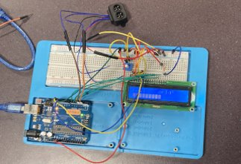

Figure 35: Original setup with Arduino and TF Luna

After finishing the wiring/coding for the sensor, we found the TF Luna could only output distance in whole centimeters. Along with this, the Arduino Uno we initially used could only utilize one TF Luna sensor at a time due to its limiting hardware. Specifically, this was the Uno's singular serial monitor, a part of the Arduino board capable of storing and utilizing incoming and outgoing electrical signals to store arrays and variables. Because of this we decided to delve into other options. We briefly looked into a slow twitch sensor, which tracks movement based on internal vibrations. The twitch sensor acts as a fluctuating resistor, meaning the faster the movement, the higher resistance produced. Instead of using the slow twitch sensor, our group used an Arduino Mega shown in Figure x below, which fixed our problem. The TF Luna could now read in millimeters and give us the results we needed, along with the capability of using up to 4 serial monitors. This allowed the original 2 TF Luna sensors to be used. Along with the Arduino Mega we were able to use up to four TF Lunas, as well as getting faster sampling speed.

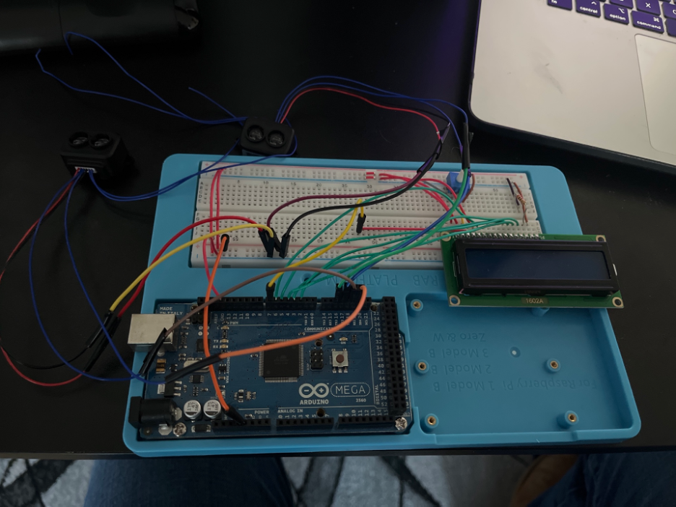

Figure 36: Arduino Mega board with two TF Luna sensors

With the hardware chosen for detecting the motion of the bar, we began to code the Arduino. Our goal for the software was to detect the initial motion and record the time of the bar along with the moment it hits the hard-stop of the rig. The difference between the time values would be equal to the time the bar was in motion. This code was completed shown in the Arduino appendix. Along with the TF Luna sensors, we attached an LCD monitor to the Arduino board, allowing us to display the times taken for the start and stop times, making it easier to see, but also providing the Arduino a capability to be run independently without being attached to the computer. This independent feature was not included in our testing scope, so it was not further tested.

### 5.1.3. Component Analysis

Before purchasing any COTS products, a static analysis of each purchased component was completed to ensure the structural integrity of the entire rig. This complete analysis can be found in Appendix A. The analysis of the pulley was completed to ensure it would not experience any load above its listed capacity on McMaster-Carr. For all calculations we chose to use an estimated input force of 46 N, which was the approximate weight of the 10 lbf weight we acquired for testing.

Based on this analysis, it can be concluded that both pulleys used to transfer the input force to the force amplification mechanism will be able to support the tension created in the cables. An analysis of the shaft was also completed to determine if the ordered shaft is acceptable for testing. This analysis was performed using equations and ideas from Reference x.

Tracing the load path of the force applied to the pulleys, we next chose to analyze the stress propagation in each fastener to determine if the fasteners would fail. A failure at the fasteners would cause the shaft supports to disconnect from the testing rig structure. For this calculation we assumed that the resultant force would be entirely transferred to tensile force in the fastener. We also assumed the material of 18-8 stainless steel, because although we did not know the material of the bolts, 18-8 stainless steel had a lower tensile strength than other steel alloys. We justify the validity of these assumptions based off the results in Appendix A.

The factor of safety of 327 shows that the fasteners will not receive any stress close to yield strength, even considering the aforementioned assumptions. For each part we ordered, the calculated factors of safety were large enough that we could confidently conclude that the parts would be sufficient for any trials performed by the other teams.

### 5.1.4. Failure Mode & Effect Analysis (FMEA)

An FMEA table was created in Excel to better identify the areas of our testing rig that could malfunction, break, or fail to provide accurate measurements. Shown in Figure X is a table with the areas we thought should be considered. Some of the concerns we had were the cable breaking, the bottom plate (which the strain gauge is mounted on) breaking, the mounting systems for the devices breaking or falling off, and the measurement system falling off the rig or not collecting data. The risk priority number was calculated by quantifying the likelihood of occurrence, likelihood of detection, and severity of impact. We determined the effects of these failures, identified their potential causes, reviewed our current detection process for each, and brainstormed recommended actions.

Table 5: FMEA table with recommended solutions

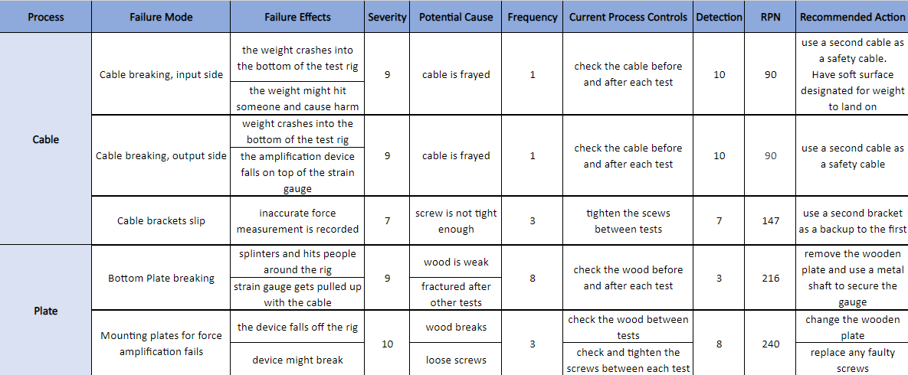

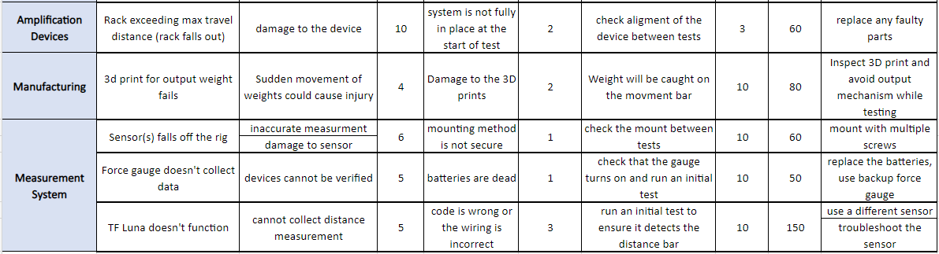

The team brainstormed issues with the following processes: cable, plate, amplification device, manufacturing, and the measurement system. If the cable is frayed or if the material is too weak, there is a potential for the cable to snap, on the input side or on the output side. The effects of this issue would cause the weight to crash into the bottom of the test rig which may result in damage to the rig or harm to the observers if it rolls off the table. Precautionary measures the team has taken to prevent this is to check the cable between tests. In the event of the cable snapping repeatedly, there is a plan for a second cable to act as a safety or to have a soft pad/cushion to catch the weight. If the brackets which secure the cable to the gauge or the weight slip, the gauge will not collect an accurate force measurement. This is likely to occur if the screw for the bracket is not tight enough, so it will be checked between tests. In the event the bracket continues to fail, there is a plan for a second bracket to be placed near the first to act as a safety.

Originally, the test rig featured a wooden plate to which the bottom of the strain gauge would be mounted. After it appeared that the plate might snap after a large force is applied to it, the team chose it switch it out for a metal t-slot bar as shown in Figure x. If the mounting plates for the amplification devices were to fail, it would likely be due to the screws not being tightened enough to the bars, or the wood cracking. Solutions to this issue are to switch out any faulty screws or change the plate.

Failures in the measurement system were discussed to determine fool-proof ways of collecting accurate measurements. There were concerns about the TF-Luna sensors falling off the rig, the force gauge collecting inaccurate measurements, or if the TF-Luna sensors fail to function. It was determined that each of the sensors/gauges would be securely mounted so that there was a very small chance that they might be disturbed from the forces acting on the rig. An initial trial would be run to ensure the sensors were working as they should be, which would eliminate the risk of an inaccurate measurement. The strain gauge would be calibrated, or zeroed, between each test to ensure that an accurate force would be recorded. Between tests, the power, wiring, and outputs of the sensors/gauge would be checked.

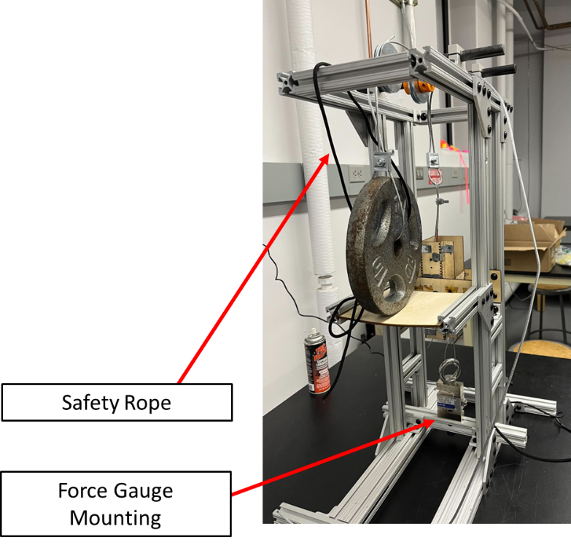

Figure 37: Changes to the test rig based on FMEA

## 5.2. Testing

### 5.2.1. Rig Assembly

The following details a step-by-step procedure of how the testing rig was assembled:

1. Main structure was created from T-slotted bars and angle brackets as according to SolidWorks assembly. The components that must be adjusted for each test (hard stops, weight plate) can be adjusted easily on the structure.
2. Mounting plates were laser cut in accordance with the two team's mounting configurations.
3. A hole for the force gauge mounting was drilled.
4. Pulleys were set on the shafts and attached to the shaft supports, which attach to the top of the testing rig structure.
5. Before testing, the force gauge and input weight can be connected to the assembly. If required, the dynamic output configuration can be assembled by detaching the static assembly and adding sensors (shown in Figure x)

The procedure for testing can be found in section 4. The following is the procedure to read the data from the force gauge:

1. Navigate to the Torbal FB1k Force Gauge product site
2. Scroll down to the Downloads tab
3. Click Software
4. Download and run the executable files
5. Open Torbal FM
6. Connect the gauge to a laptop using the RS232 cable and the adapter
   1. Click "Connection" at the top of the screen, then "Advanced" to see which COM port is shown in the drop down. Return to the connection screen and ensure the COM port value is set at the value you saw in the drop down. Detecting the gauge will take a few tries.
7. Running a test
   1. Open Excel then return to Torbal FM. Enter a sampling time, calibrate the gauge by clicking the "Zero" button", hit "Start" to begin the test, click "End" when the test has completed.
   2. File > Export to Excel. For each test make sure you have a new Excel sheet open otherwise it will enter over the previous values. In addition, the data does not export if Excel is not open

### 5.2.2. Force Data Collection

Our team decided to use a force gauge as it met our requirements. This sensor, displayed in the figure below, uses a strain gauge to gather data. It consists of a metal body, to which foil strain gauges are bonded. The metal body slightly deforms when a force is applied, and acts as a spring so that it returns to its original shape. The change in shape causes the resistance in the conductors to change and creates a differential voltage variation through a circuit. The change in voltage is proportional to the force applied to the unit.

There are two different measurement devices our team has access to. The first one is the FM-207 model of digital force gauge made by LANDTEK. The gauge has a maximum force of 500kN, and a resolution of 0.1N. This gauge can only measure output as a display, so a second force gauge was acquired for further testing. The second device is model FB THOR from TORBAL which has a maximum force capacity of 900N and a resolution of 0.2N. This device, however, can export data. For our purposes, we will be analyzing a force/time graph produced from TORBAL FN software.

### 5.2.3. Input Force Calibration

To prepare for testing, the exact force input from the drop weight had to be calculated. This was achieved by securing the drop weight to the force gauge with a wire-rope. The force gauge could then be used to record the input force generated by this weight. We then ran a series of 5 calibration trials. For each trial, force was applied by the drop weight only after the force gauge was zeroed. The results from the trials gave an average input force of 41.2 N, with a standard deviation of 0.97 N shown in the table below.

Table 6: Trials for input weight validation.

|  |  |
| --- | --- |
| Trial | Force (N) |
| 1 | 39.8 |
| 2 | 41.4 |
| 3 | 40.8 |
| 4 | 42.4 |
| 5 | 41.6 |
| Average | 41.2 |
| Standard Deviation | 0.969536 |

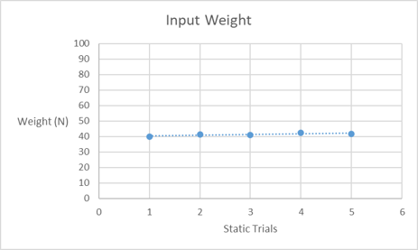

Figure 38: Trials for input weight validation.

From this static calibration, the other teams had an input force to use for static analyses. Using this input force, it is possible to estimate the amplification factor of the force amplification mechanism, as stated in the Static Test section.

### 5.2.4. Static Test

The goal of static testing was to determine the amplification factor of each team's design. This involved securing the force input to the amplifier input, while connecting the amplifier output to the strain gauge. The force gauge was mounted to the bar at the bottom of the rig so the whole system creates one connection. Before the start of each trial, the force gauge measurement procedure was followed to ensure data is collected for the duration of the trial. To begin each trial, the input weight was dropped. This would apply a tension force to amplifier input. The resulting static force load output by the amplifier was then measured by the force gauge. The data gathered from this will determine if the designs created by the rack/pinion and pulley teams can produce 2.5x the input force.

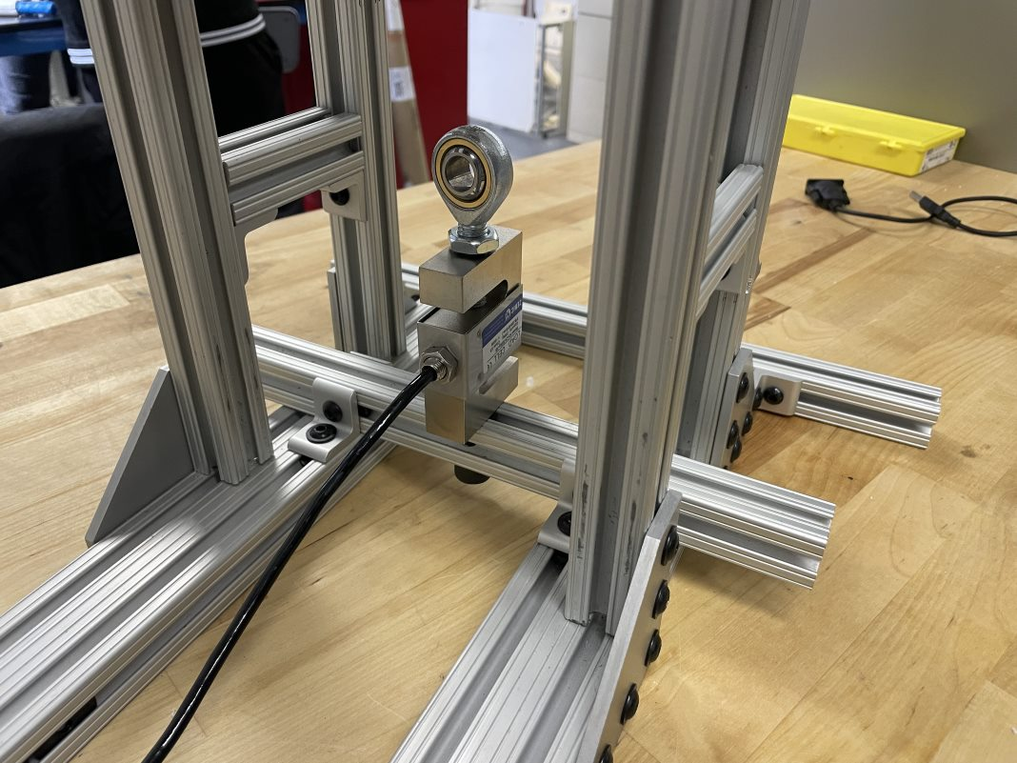

Figure 39: Static test setup with output bar fixed

### 5.2.5. Dynamic Test

In addition to static testing, a dynamic test was performed to determine the response time of the amplification device. The set-up for the dynamic test changes slightly from the static test. The Torbal force gauge was mounted to the same t-slot bar as in the static test, however the bar was not fixed to the rig. As shown in the figure below, the bar will rest on a hard stop. As the input weight is dropped, the entire system will be pulled up by the tension force until the bar hits the hard stop 65 millimeters above the starting The Torbal force gauge was used to measure the times when both the tension force and hard stop impact force were applied. While this information was useful, it was not the primary form of measurement. Instead, the main method of measuring response time used two TF-Luna sensors. These sensors were placed on a mount to record the motion of the slot and determine the amount of time it takes to move 65 millimeters.

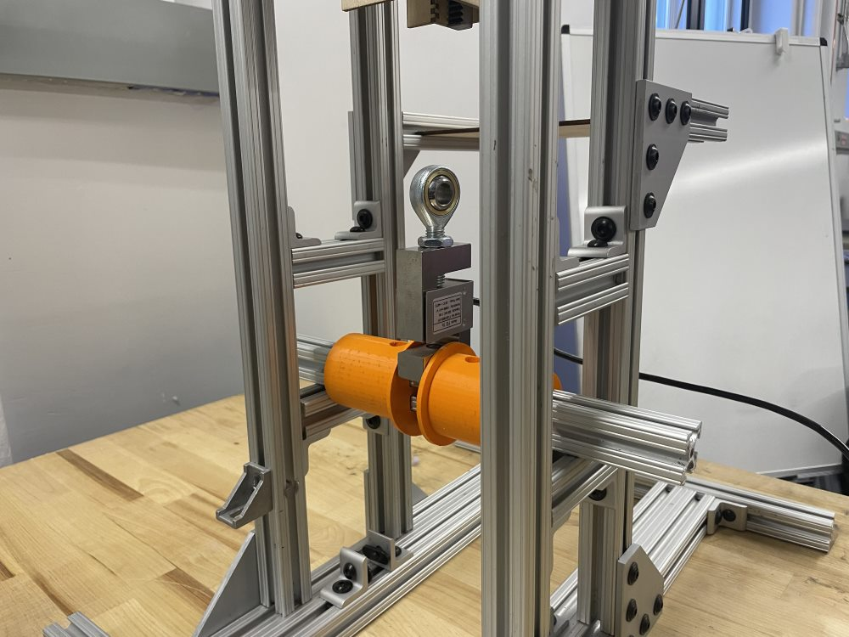

Figure 40: Dynamic test setup with output bar free

# 6. Recommendations

## 6.1 Force Mode and Effects Analysis (FMEA)

We conducted a Failure Mode and Effects Analysis (FMEA) to identify potential issues or failures and their effects on the system or process. We identified the severity (SEV) of the effect on all the shareholders, Failure probability occurrence (OCC), Difficulty to detect failure (DET), and use this to calculate the risk priority number (RPN=SEC x OCC x DET) and criticality (CRIT = SEV x OCC). Since the analysis if for actuation of a safety system the SEV is a larger number for all the components. The Risk Priority Number is classified by the following table:

Table 7: FMEA criteria for amplification system

|  |  |  |
| --- | --- | --- |
| Score | Risks | Actions |
| 250+ | High | High priority remedial action  Proceed with care and additional control advised |
| 100 - 250 | Medium | Take remedial action at appropriate time |
| <100 | Warning | Risk acceptable: Residual risk. If possible, risk reduction, should be considered |

We have also provided recommendations to reduce the DET to eventually reduce the RPN. Other than the specific recommendations for each component, a general recommendation is to do regularly scheduled maintenance to visually inspect the parts and to repair or replace the damaged components

### 6.1.1 Bearings

The OCC for bearing is calculated using research papers dedicated to bearing failure, which shows 0.5% bearing replacement due to damage or failure. The main cause for bearing failure is overheating, deformation, and misalignment. These can cause the bearing cages to break. Since the bearings are closed off, the detection mode for these is difficult, which is why it requires periodic inspection.

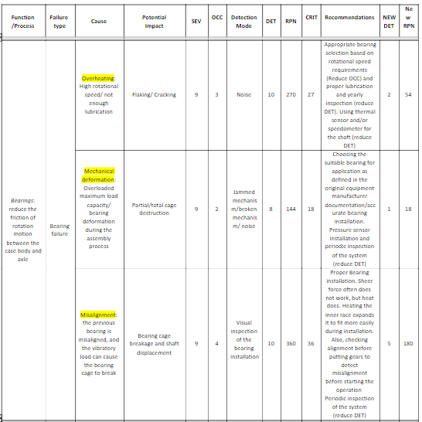

Figure 41: Bearing FMEA

### 6.1.2 Carriage/Rail, Shaft, and Fasteners

Similarly, we obtained OCC for parts like shaft, bore, rail, and carriage based on the likelihood of them failing due to material deformation or interference issue.

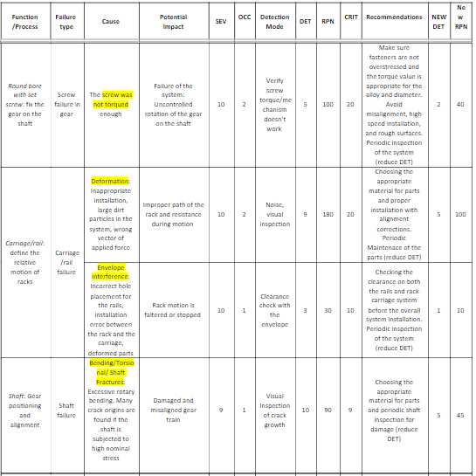

Figure 42: FMEA for carriage, rail, shaft, and fasteners

### 6.1.3 Gears and racks

We have looked at the OCC for the gears and racks based on the gear tooth failure for spur gears.

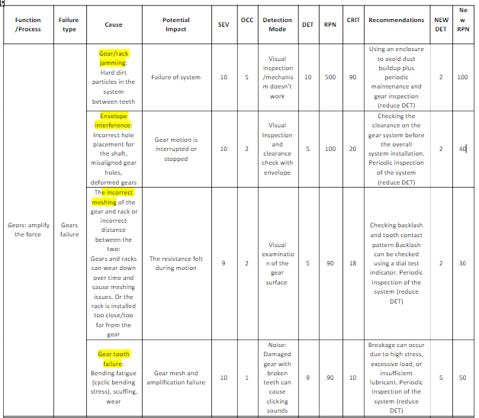

Figure 43: FMEA for gear and rack

## 6.2. Test Rig Recommendations

### 6.2.1 Design

The original test rig design can be improved for better ease of use and more accurate and consistent testing results. A few improvements were identified by the testing rig team and are listed as follows:

1. Mounting amplification devices onto the testing rig can be improved. The current system has mounting plates between two vertical support bars. These bars are too close together so there is limited room and visibility when attaching mounting plates. Attaching the mounting plates on the exterior, instead of interior resolves this issue.
2. Pulley friction was an issue the team faced throughout testing. The lubricated bushings were not sufficient and tolerancing was poor. If bearing with improved tolerancing were used instead of bushings, these issues would be resolved.
3. During the dynamic tests, the output hard stops are open resulting in the output bar rotating freely. If a plate with a slot was placed on the side of the structure, the motion of this output bar could be constrained to the slot.
4. Weight drop could be improved to be more consistent. While the wood plate was originally planned, it was discovered there was too much friction and it resulted in the weight swinging. The design of a different drop system would improve consistency in results.

### 6.2.2 Measurement

The original test rig design can be improved for more accurate measurements. A few improvements were identified by the testing rig team and are listed as follows:

1. Synchronization of timing devices would improve the accuracy of time measurements.
2. A second force gauge, this one being connected to the input subassembly, could be added. If this force gauge was synchronized with the output gauge, it would be a much more accurate way of measuring how long it takes for the force to be transferred through the system.
3. The positioning of the TF Luna sensor can be improved. The connection to the test rig was done with tape and manually adjusted to the proper position. If a proper mount is built, the sensors would be in a repeatable position and would not need manual re-calibration before every test.
4. Other sensors should be explored. Particularly hall effect sensor or encoders would be a better method of tracking the true motion of the amplification devices.

### 6.2.3 Operation

The testing rig can be optimized to make it easier to perform accurate tests with minimal setup. A few improvements were identified by the testing rig team and are listed as follows:

1. For the pulley amplification, the input cable must be kept in constant tension before dropping the input weight. The input system can be redesigned so that the weight can be attached while the amplification system is still set up.

Many attachments (crimps and other cable attachments) were required for the rack/pinion force amplification system, which required a lot of tightening before conducting a test. This could be improved with a force input system more suited towards the rack/pinion force amplification system.

# 7. Conclusion

The testing rig was able to meet all the detailed requirements. For structural, the mounting system was fully adaptable to each amplification design and could support a full-scale amplification mechanism. Looking at input force, the rig was able to apply an accurate input force of 40N consistently throughout trials. The rig had the ability to record the output force dynamically as well as record the time it takes to travel the distance of 65 mm.

The mechanical force amplifier achieved most of the customer requirements, proven by testing results. The main requirements were to insert the mechanical amplifier assembly in the decided envelope size (185 mm x 42 mm x 64.5 mm) and to have a minimum force amplification factor of 2.5. The actual amplification factor after testing equals 2.58. Another requirement was that the mechanism should work without lubrication. The preferable requirement for a travel distance equal to 65 mm still needs to be achieved, where the working design could only travel 23 mm for dynamic testing. Moreover, the desired time response should be less than 0.1 seconds, but the average time response obtained through tests was 0.112 seconds. However, the reason for this time response can be explained by how the testing rig transferred the input force to the amplification system. The response time was affected by the time it takes for the cable to enter into tension, as well as the friction from the input pulleys. Even despite the issues with testing listed above, the rack and pinion system is still feasible as a potential force amplification mechanism for the safety braking system.

# 8. Reflection

Nikita:

I learned how the safety system works in OTIS elevators. I discovered different ways to amplify the force that can be integrated into the system. I learned how to 3D print parts for prototypes. I learned how to weld the steel and adjust the parts. I learned to make testing protocols and followed them during the testing. I learned how to read the data and analyze them. I improved my analytical and communication skills.

Aashish Singh Alag:

I now know more about safety measures for elevator systems, both the current and new systems implemented. I gained a lot of CAD experience through this project, which helped me create the assembly. I've also grown more adept at ordering needed components from reliable sources. Additionally, I have gained some expertise in 3D printing prototypes. Additionally, I've developed some workshop skills by modifying the parts to fit the needs. I now know more about the testing setup and protocols that were taught to us at WPI. I've also learned how to conduct FMEAs for various systems.

Zeb Carty:

This project gave me a lot of practical experience in design, assembly, as well as improving my skills working in a team. I used experience from Statics and Stress Analysis to complete the analytical part of this report, and personal experience for the assembly of the testing rig/supporting structure.

Alexander Lucero:

This project builds on my experience and knowledge in mechanical design. I utilized SolidWorks CAD software to design and modify the testing rig. I learned how to utilize resources readily available to rapidly develop testing systems. I learned how to detect issues before they make it to manufacturing and how to solve problems quickly as they arise. I also reflected on testing challenges so in future design projects I will take these considerations into account. Finally, I improved on my communication skills and got more practice with professional presentations.

Cooper Langner:

This project brought together many different aspects of what I learned about engineering design during my time at WPI. I learned how to rapidly iterate through CAD models shared between team members. I applied the knowledge I acquired in my basic engineering classes in a real-world situation for the first time. I learned how to work with a team to divide large amounts of work over the course of weeklong period and synthesize the results of that work into a useful product. Lastly, I practiced keeping a daily engineering journal for the first time in my engineering career.

Karl Ghosn:

I first learned how elevators work. I research how the whole system functions, from safety system and governs the new system that OTIS has patented. I implemented the knowledge I learned in mechanics, material properties, dynamics, and stress analysis in order to confirm the success of the components we used in the system and make sure it will not fail. This class also gave me experience in teamwork and work distribution in general simulating the real-world job space, how and where to look for parts, 3D modeling.

All this was made easier by having Dr Pradeep by our side, guiding us throughout the project. Thank you Dr Pradeep.

# Appendices

## Appendix A: Authorship Table

|  |  |  |
| --- | --- | --- |
| Section | Author | Edited |
| **Abstract** | Aashish |  |
| **Acknowledgements** | Karl |  |
| **Executive Summary** | Aashish & Alex | Zeb |
| **1. Introduction** | | |
| * 1. Mission Statement | Aashish | Cooper |
| 1.2. Project Goals | Karl | Cooper |
| 2. Background and Literature Review |  |  |
| 2.1. Relation between Electronic Safety Actuation (ESA) and mechanical amplifier | Nikita | Cooper |
| 2.2 Rack and pinion | Aashish | Cooper |
| 2.3 Types of gears and gears information about dimensions | Nikita | Cooper |
| 2.4 General information about bearings | Nikita | Cooper |
| **3. Methodology** | | |
| 3.1. Phases | Zeb | Cooper |
| 3.2. Design and Implementation | Cooper, Aashish, Karl, Nikita | Cooper |
| **4. Analysis and Result** | | |
| 4.1 Static Testing Procedure | Nikita, Cooper | Cooper |
| 4.2 Dynamic Testing Procedure | Nikita, Cooper | Cooper |
| 4.3 Static Testing Results | Nikita | Cooper |
| 4.4 Dynamic Testing Results | Nikita | Cooper |
| **5. Testing Rig** | | |
| 5.1.1 Requirements | Zeb | Matthew L,  Katie |
| 5.1.2 Design Process | Zeb & Alex | Matthew L,  Katie |
| 5.1.2.1 Structure | Alex | Matthew L |
| 5.1.2.2 Mounting | Alex | Matthew L |
| 5.1.2.3 Input Force Subsystem | Richard & Zeb | Alex |
| 5.1.2.4 Output Force Subsystem | Katie & Alex | Matthew L |
| 5.1.2.5 Sensory | Matthew L & Achilles | Zeb |
| 5.1.3. Component Analysis | Zeb | Matthew L |
| 5.1.4. FMEA | Katie | Matthew L |
| 5.2.1 Rig Assembly | Zeb | MatthewL |
| 5.2.2. Force Data Collection | Katie | Alex |
| 5.2.3. Input Force Calibration | Richard | Katie |
| 5.2.4. Static Test | Richard | Katie  Matthew L |
| 5.2.5. Dynamic Test | Katie | Richard |
| **6. Recommendations** | | |
| * 1. Force Mode and Effects Analysis | Aashish & Nikita |  |
| * 1. Test Rig Recommendations | Zeb & Alex |  |
| **7. Conclusion** | Zeb & Nikita |  |
| **8. Reflection** | All | All |
| **Appendices** | | |
| B: COTS Analysis | Zeb & Alex |  |
| C: Arduino Code | Achilles | Achilles & Matthew L |

## Appendix B: COTS Analysis



Figure 44:Resultant load diagrams from Reference (a), Section 4.2



Figure 45: Formula for testing rig pulley configuration from Reference (a), Section 4.2

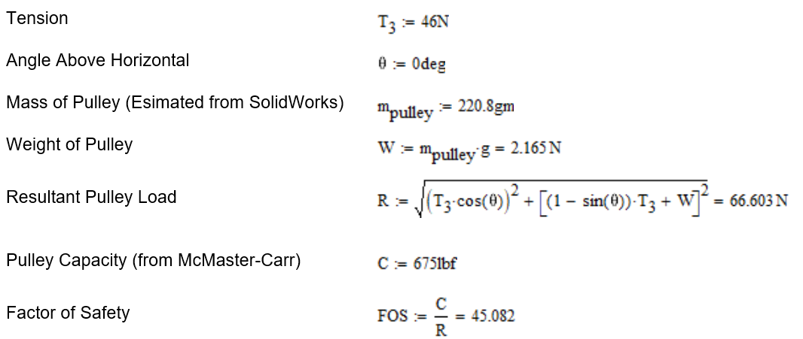

Figure 46: Pulley analysis

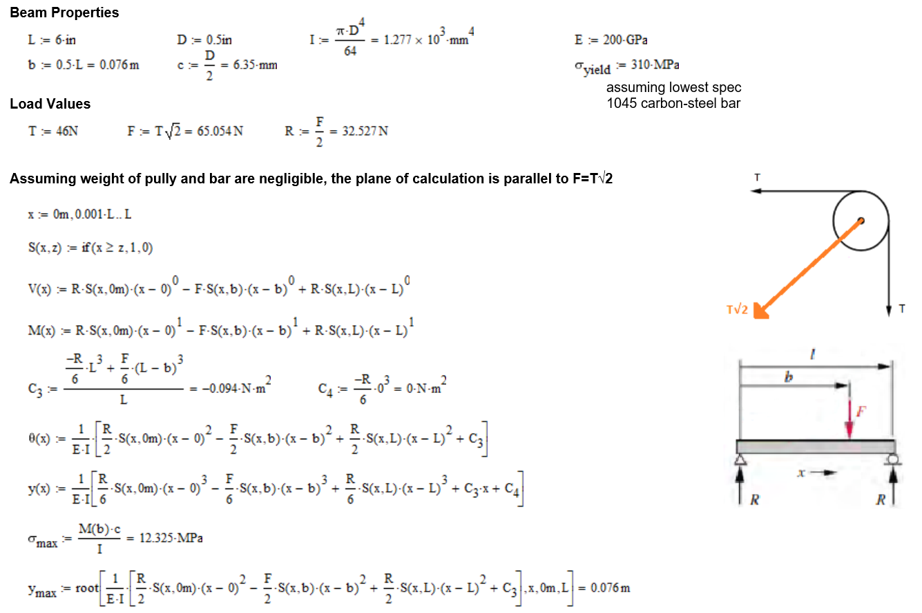

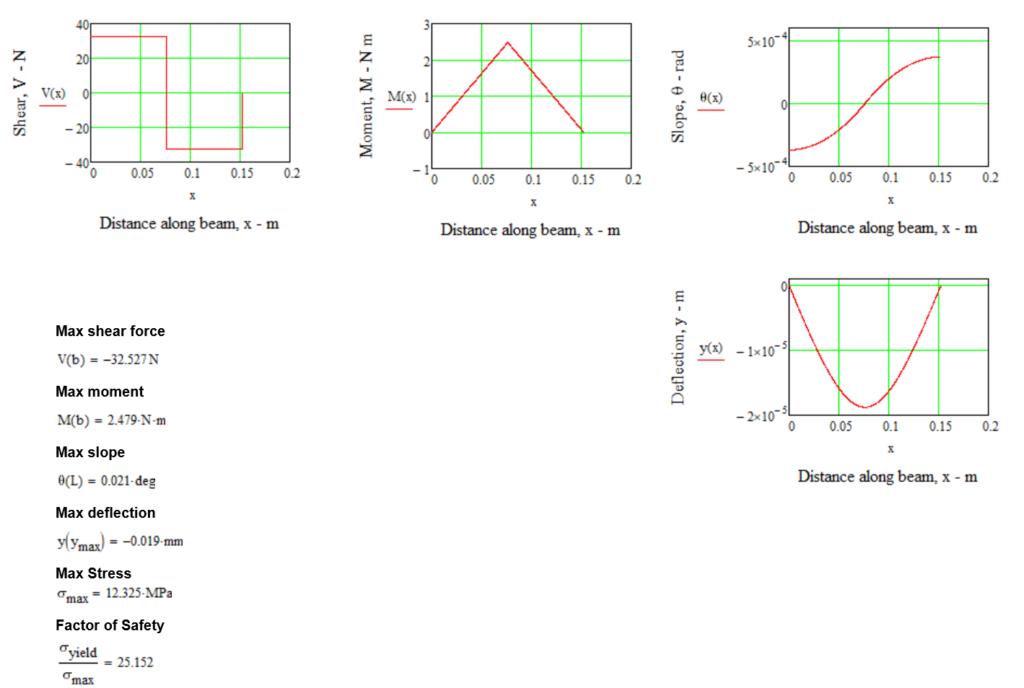

Figure 47: Shaft analysis

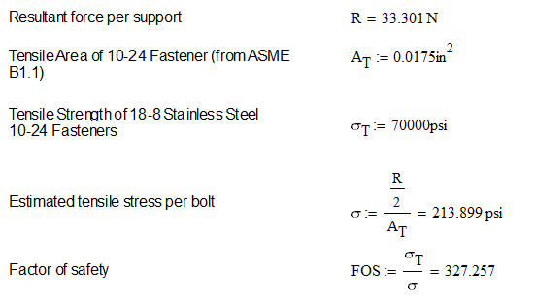

Figure 48: Fastener analysis

## Appendix C: Arduino Code

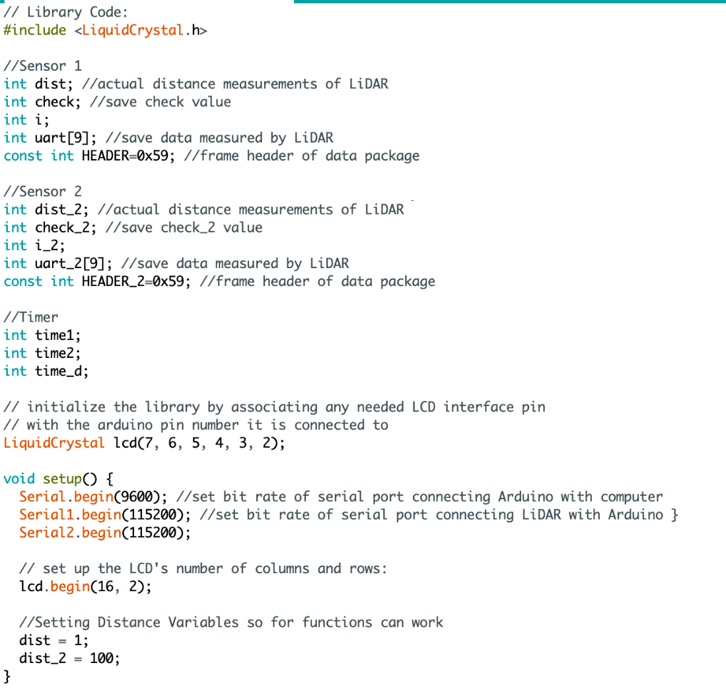

Figure 49: Setup and Variable Initializing at startup

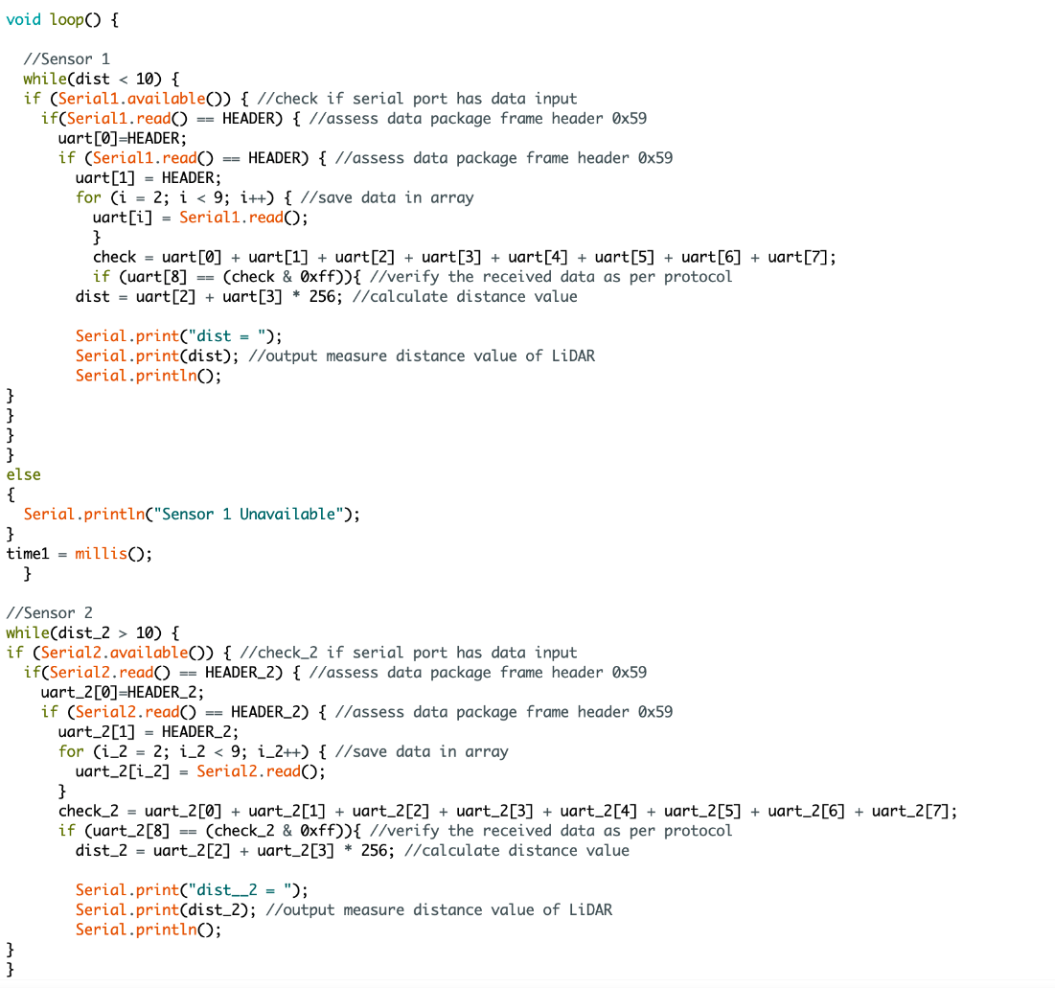

Figure 50: Looping Code for Sensors 1 and 2

# References

(a) Conveyor Equipment Manufacturers Association. *CEMA Standard B105.1 Specifications for Welded Steel Conveyor Pulleys With Compression Type Hubs.* 2015.

(b) Norton, Robert. *Machine Design: An Integrated Approach.* 6th ed., 2019.

(c) *Product specification SJ-GU-TF-Luna.* Benewake Co., https://www.mybotshop.de/Datasheet/Benewake_TF-Luna_Datasheet.pdf.

(d) *Stress Strain Diagram of Different Materials*, https://www.tf.uni-kiel.de/matwis/amat/iss/kap_3/backbone/r3_1_3.html.

(e) *Unified Inch Screw Threads (UN, UNR, and UNJ Thread Forms).* ASME B1.1-2003, American Society of Mechanical Engineers, 2003.